1. Introduction : **FireChat.**  
     
    **General description and background:**  
     
   ChitChat is an android , kotlin platformed based application that will allow users

To communicate through text messages, video messages , share and post in social media.  
  
  
 **System purpose:**

the system will allow users to create personal accounts and a “sign option”, chat with others via general chat rooms or as private massages according to their will.

Users can share various media files and post through social media.

1. **Chapter A: Software Analysis**  
     
   **Development languages:**Kotlin - latest new popular platform for android users in the future because

of its syntax. It has modern language features and much safer code.

* Android studio editor for windows. **System requirements required to implement the project:**
* Android studio (latest versions required 4.0 and above)
* Kotlin writing language
* Firebase by Google

**What is the project supposed to innovate or improve?  
  
FireChat** is an android , kotlin platformed based application that will allow users To communicate through text messages, video messages , share and post in social media .  
  
 the system will allow users to create personal accounts and a “sign option”, chat with others via general chat rooms or as private massages according to their will.

Users can share various media files and post through social media.  
  
**FireChat is based on FireBase real time platform and does not force the development process to acquire private servers and databases which downgrade the dev cost to a zero level expense . future technologies in this method that feature usable functions such as video calls and messaging & big file sharing will attract a lot of users. FireChat is aiming for mass share via social media by users.**

**An overview of the current market situation, what problems exist ? :**Today there are a lot of other companies given the same services and most of them are without a monthly pay.  
Examples for other brands :

“Whatsapp”

“Viber”

“Skype”

“Telegram”

“Wechat”  
  
The monthly paid use and the expensive purchases are a problematic **ACCESSIBILITY** to those apps and downgrade the popularity among users.  
  
Fire chat will cost only a dollar in the play store. Half for my dev expenses and half for charity .

**Functional requirements:  
  
The application needs to be an easy to use, user friendly real time fast and as minimal as possible.  
This way I learned helps me overcome dev obstacles in a way that dont require me to treat every element in the development. In this way I can easily access my pages and implant features or fix bugs quickly.**-android studio 4.0

- firebase database

- storage

- authentication

- android version above 5.0

- Groupie library

- picasso library

- recycler view

- windows 10 **Problems that occur during development :**

* **problem when uploading image to the firebase storage**

- firstly saved the uri of the user’s picture. Passed the complete part to the firebase storage and made it as a complete SucsessListaner on reference in the firebase storage.

* **problem while creating new User into the firebase**  
   need to save the user id, move it into the firebase database part,make it as a complete SucsessListaner on reference in the firebase storage.
* **Setting the Groupie libraries** - wrote the official documentation of Groupie libraries
* **Sign in with google**Unable to sign in due to unknown error
* Unable to get the default web client id
* After removing the previous data we cannot get the user that are signup in our application
* Because of not uploading data on the Firebase Database.
* We have to make a smart plan in which we don't need to implement all the functionalities from scratch but only change the code.
* Also need to change the messages method and getting current user key
* And storing into the firebase database.
* Also need to fetch the user profile images and set them on the images view. it's also a challenge fetching the google profile image.

* **Fetching the users Data from the Realtime Database -**

Made an instance of our firebase database and passed it by the complete path with the userId.  
Set it to the edittext/textview

* **App crash due to not writing something in the override method**

We write in the override method then it will start working

* **Using Picasso Library(in general. Came as a recommendation which i was not familiar at all)**

documentation of the Picasso library

* **Loading image to the Picasso**

Passing the wrong URl of the image to the Picasso that’s why it's not working then I pass the right URL of the picture.

* **Url of the Profile picture is fetching properly but not showing on the ImageView**

I sent the wrong url of the picture to the Firebase Database thats why its not working then i made it right.

* **Not showing the image on the image view**

Pass the wrong path of the image view to the picasso then make it right.

* **On chat _log _main activity time display did not set right.**Time code was graphically weird showing wrong time and displayed weird also.
* Time conversion in koltin needed to be learned right.
* Didn’t find any way to get only hours and minutes of current time
* Kotlin provides a String with complete hours minutes and Date
* i need only hours and minutes
* **Notifications**Notifications don't work because when the first message arrives from the user it shows the notification only that time.

Then we copy code from LatestMessage activity to ChatLog Activity then it works fine

* **Editing user profile activity**  Error While getting data from the firebase database and showing into the Edit Text.

Error on Fetch profile url and set into the imageview.

Error While updating data on the firebase can’t get the message.

* **Sharing through social media’s various technologies and functionalities.**  
  I was only able to share files on social media via the android operating system functionalities when using FireBase storage but, we can internally share some files within our app.
* **Sharing files between users:**  
  When picking a file from the user1’s mobile gallery/folder to be uploaded onto firebase storage to be forward to user’s2.  
    
  Firebase does not allow me to share all types of files and I had to maneuver between choices of data flow. Purchasing technologies that solve this to be implanted are good ideas but not genuine so i decided to use android operating system functionalities. Future dev maybe will bring a solution.

**possible solutions:**Proper and effective design of the entire system given the issues listed above.

* Proper development of the software that provides maximum and best response to each of the system's scenarios and requirements.
* QA
* Design a system architecture capable of allowing any customer to consume the chat service and remove system dependency
* Automatic backup.

**Selected technology solution:** Solution topology:

System Deployment Where the system deployment of the aforementioned system-level deployment components will be implemented.

For example: Web site development - a system consisting of a user interface server that takes a database of Internet communication range and the system will be implemented on the Internet. Please showcase a system diagram:  
  
- system deployment will be mostly via our PC’S windows, system editor which will also be developed in.  
Our editor on our pc of choice was Android Studio version 4.0 as our idea was an android mobile app.

* Kotlin developing language version 1.3.5

- google’s android mobile operating system . developed for versions 5.0 lollipop and up.  
  
- google’s FireBase version 16.0.1 account.

**Selected topology diagram:**

  
**dfd:**  
  
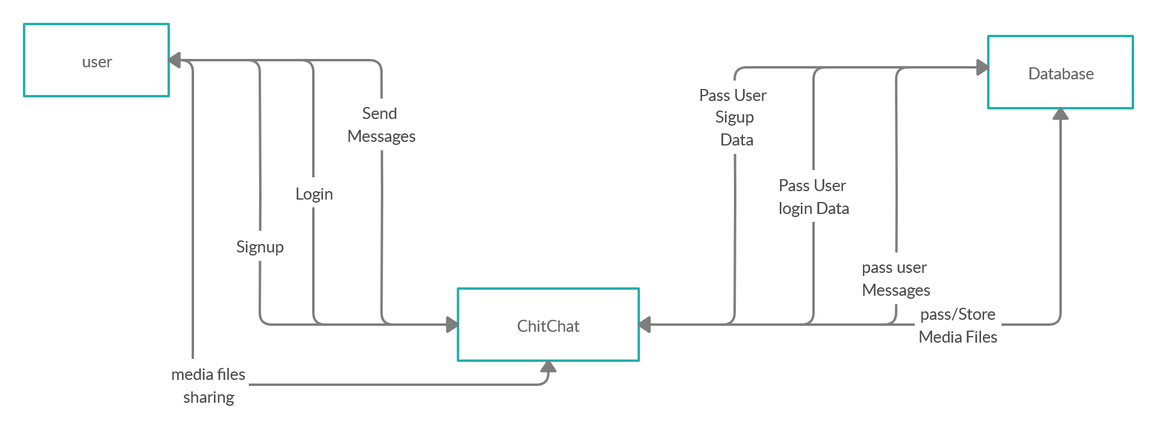  
  
  
  
  
  
  
  
  
 **Technologies used:**Android studio : free. Most popular platform for building android apps in java, c++ and kotlin. Easy to use and understand.

* We chose an Android app. Android has the most users compared to IOS for example. Easy to build android apps. Uploading our application on play store easily .
* Kotlin - compared to other platforms , it has simple and small syntax.
* Firebase - free. secured*. Real time database*. Google oriented.  
    
    
  - Android Studio version 4.0  
  - Kotlin developing language version 1.3.5  
  - google’s android mobile operating system . developed for versions 5.0 lollipop and up.  
  - google’s FireBase version 16.0.1 account.

**The architecture of the application:  
  
  
Three-tiered model architecture - a model that fits the intended application:  
  
\*** UI - USER INTERFACE

* + Server
  + Firebase

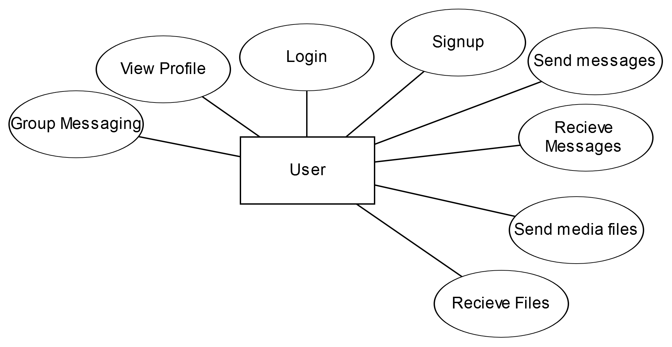

|  |  |  |
| --- | --- | --- |
| UI | SERVER | FIREBASE |

|  |  |  |
| --- | --- | --- |
| SHOWING USERS SCREENS INTERACTED TO USERS.  SENDS TO SERVER | CONNECTS BETWEEN THE UI AND FIREBASE  SENDS BACK TO THE UI.      SENDS DATA TO FIREBASE | FETCH AND SENDS FROM THE DATABASE  SENDS BACK TO THE SERVER |

**Distribution into programs and modules:  
User module -**\* Log in

* Sign up
* Send messages
* Receive massages
* Media file sharing
* Sharing files on social media
* View user profile
* View all users
* Sign in via social media  
    
    
    
    
    
    
   **Description / reference to information security issues:**- not having any.  
    
   **Resources required for the project:** <https://github.com/>

<https://stackoverflow.com/>

<https://firebase.google.com/>  
   
[https://Youtube.com/](https://youtube.com/)  
  
 **Work plan and steps to realize the project:**

1. Idea - came across with the idea when I looked for a nice up-to-date project in android studio which i think is one of the most interesting platforms.  
   A chat application is what i found to be a good lesson for development and self learning of android apps.  
   Came from from the need to contact my socials in a private way .
2. Similar apps I found and inspired by was basically whatsapp. Whatsapp is a very well integrated and designed app which is very popular in the whole globe and has been developed by a unique method of logging which forced it users into a certain way of using and sharing through social media and got very popular in that way.  
   I believe that putting a big mark on sharing files through the social media in my app will increase the visibility of the app’s usage among users in the social networks and that is what will make it look like it has been used “everywhere by everyone”.
3. Writing system requirements -   
   * understanding the whole projects structure by finishing the youtube series that sparked up the idea at the beginning and made me come to a point where i got the whole platform working and i now know what i need to write, design, collect to my database, working with my database and solving dev problems. Checks were made at every point. According to the guidelines given to me for the project.
4. First created a firebase account. Watched tutorials and read google documentation about using it. Later on I got stuck and paid an online tutor for teaching me how to get it working in android studio.
5. Created a new project on firebase and passed our project package name to firebase.
6. Now that we got our kotlin synced with firebase we can start writing our app.
7. Wroted MainActivity . inserted sign up functionality inside .  
   **- came from work progress docs :**

**Splash Screen:**Steps

* Make a activity name as “SplashScreen”
* Download logo’
* Paste in the drawable directory of our project
* Write code for the fade_out transition
* Open manifest change the icon of our application
* Make Splash_in xml file and write code for the it
* Open SplashScreen.kt write code for Splash in and out and move to the LatestActivity
* Hide the ActionBar.

**Sign In with google:**

Steps

* Make a activity name as “SplashScreen”
* Download logo’
* Paste in the drawable directory of our project
* Write code for the fade_out transition
* Open manifest change the icon of our application
* Make Splash_in xml file and write code for the it
* Open SplashScreen.kt write code for Splash in and out and move to the LatestActivity
* Hide the ActionBar.

**Login with google:**

Steps

* Open Sign in with Google website
* Copy the dependency into my project
* the n click n add project in the website and add my project name
* Add package name and SHA-1 code in the Form
* For getting SHA-1 code click on the gradel at the right side of the android studio
* Expand the TAsks and android and double click on signin report it give the SHA-1 code
* Then we move to the Sign in at the website and copy the code given by the google
* And add button given by google
* Also set click on listener on the google button that take us to the sign in with google page on out mobile phone

**Chat log Activity:**

Steps

* Make new Activity name as ChatLogActivity
* Make send message EditText and button for send message
* Make a recycler view for the showing chat
* Make a xml file that show received messages
* Make a xml file that show send messages
* Make Put Extra
* **Pass user information from New Message Activity to ChatLog Activity using PutExtra.**
* Getting the user information from the previous activity
* **Use dummy data for send and receive messages**
* Send message, From id, to id, timestamp to the firebase
* Then pass the receiver message to the receiver side and sender to sender side
* Change the title of the action bar to the username
* **Add exception handling. User can’t send a message until they write something on the Edit Text of the message.**
* Make Time of sending and receiving message looking good. And did the alignments of the time Text View

Difficulties:

* Need to alignment the time in the textField

**Messages Activity:**

Steps

* Make new Activity Name as LatestMessagesActivity
* Write code for keep user logout if he is not registered or logged in
* Make new directory into the res folder name as menu
* Inside the menu make new xml file name as nav_menu and make two menu items
* Then go back to the our LatestActivity and call the nav_menu
* Make user able to sign out of his profile
* Make new Activity of New messages
* User able to move to the new message activity
* Make a recyclerView
* Download the Groupie library
* Download the Picasso library
* Make xml file for the showing the row of the users
* Create method that fetch data from the Database
* Make an adapter that fetch the user username
* Pass the adapter to the Recycler view
* Users fetched successfully

Difficulties

* Setting the Groupie libraries
* Cant access the xml file
* Fetching the users Data from the Realtime Database
* App crash due to not writing something in the override method
* Using Picasso Library
* Loading image ot the Picasso

**Forgot Password Feature:**

Steps

* Make TextView in the xml file of login “Forgot Password”
* Make new popup dialog for enter the email
* Open login Activity.kt file and set on click listener on text
* Make builder that open the popup Edit text and make new button Reset and Close
* When user enter the mail and hit reset button a method called ResetPassword
* In that method we get the email entered by user and send an Reset link of password to his email

**Time signature inside the Message box:**

Steps

* Open chat log Activity and understand the code for sending time in millis into firebase
* Try to change the code that is in millis but given error in some classes
* Then in chatMessage class pass two values instead of one of type Long one for Hour and other for Minutes
* Also change the classes chatFrom and ChatTo pass them two values

Difficulties

* Time conversion in koltin
* Didn’t find any way to get only hours and minutes of current time
* Kotlin provide in String with complete hours minutes and Date
* But i need only hours and minutes

**Latest Message Activity:**

Steps

* Create Recycler VIew in the Latest Message Activity xml file
* Create new xml file name as latest_message_row
* Make a row that show the latest message
* Containing username message and profile picture
* Make method in the latest activity to show a dummy data
* Then get latest messages and set on the row
* The message will show the Latest message screen
* Use hashMap for saving the messages and for show the latest messages on the Latest message activity
* Load the username on the latest message Activity
* Make Divider between the Recycler View in the Latest Activity
* Solve the problem of showing images in in the imageView
* Add click listener on the recycler view row to show the chat of that person
* Make APK of our app
* Add some Styling in the App
* Work on login Activity
* User can login into the application using his email and password

**Edit User profile Activity:**

Steps

* Make new activity Profile and xml file
* Make beautiful profile view xml when we can get and show user data
* Also understand and work with Linear layout
* Then go to profile.kt file and write code for the getting data from the firebaseDatabase and make update button and perform set action on it
* And update the profile into the firebase Database with password

Difficulties

* While getting data from the firebase database and showing into the Edit Text
* Fetch profile url and set into the imageview
* While updating data on the firebase can’t getting the success message

**Setting up for the notifications**

Steps:

* Open LatestMessage Activity and write code for showing the notification on the mobile notification bar
* Make builder in the koltin file and customize it according to our need
* Pass the builder username and message that he sent
* Then pass the builder to the notification manager
* Also get permission from the mobile setting for notifications
* Also make intent for the user when he clicks on the notification it take user to notification window

Difficulties:

* Notifications don't work because when the first message arrives from the user it shows the notification only that time.
* Then we copy code from LatestMessage activity to ChatLog Activity then it works fine

**Sharing Files to other social media:**

Steps

* Understanding the implicit Intent
* Make new Activity share files
* Make xml UI for the Share activity
* Add Image view and a button for sharing the files
* In Share file Activity make new method that show image in the image view
* And setOnClickListener on button for sharing the image to the other social media using implicit intent
* When user click the button my app open mobile sharing window and all the apps installed on the user’s mobile in which user can share image.

Difficulties

* Working with implicit intent that is hard to work. Took much time to become familiar with this.
* Having difficulty getting the data from the mobile gallery
* And then pass to the Implicit intent with the proper extension
* Hard tot the get the file extension that user pick from the gallery
* Hard to pass the filele to the other apps from our application
* Hard to work with bitmap
* To share an image for examp, i was needed to pick an image out of my gallery,and sent it to imageView.
* In google’s developer’s website documentation i was told to convert my image to image URI.
* Used ImplicitIntent for to share image to other applications on the phone (our solution!!)
* Sharing text to other apps .

1. **I made a new APK of my app.  
     
   12. Sent it to my friends.  
    My friend downloaded it via bluetooth and installed it on their smartphones.   
     
   13. I made an account inside chitchat and tried to sign up.  
     
   14. Texted my friends , made sure they have received it successfully  
   And reply to me.  
     
    15. Started design of the interface and figuring out a new Logo.  
     
   16. We started making customization and removed small bugs that appear while testing the app.  
   17. Updated the APK , downloaded again and tested it. All worked.**

**Planning the tests to be performed:**

|  |  |  |  |  |  |
| --- | --- | --- | --- | --- | --- |
| **Log in** | **Sending a massage** | **Deleting a user** | **Making changes within the system’s core** | **Entering the system** |  |
| **yes** | **yes** | **yes** | **yes** | **yes/no** | **admin** |
| **yes** | **yes** | **no** | **no** | **yes/no** | **user** |

**Version control:**

With Firebase's DataBase the information is updated automatically no control is required.

**Chapter B : Details of the pages in the**

**Application   
  
 GUI SCREENSHOTS :  
  
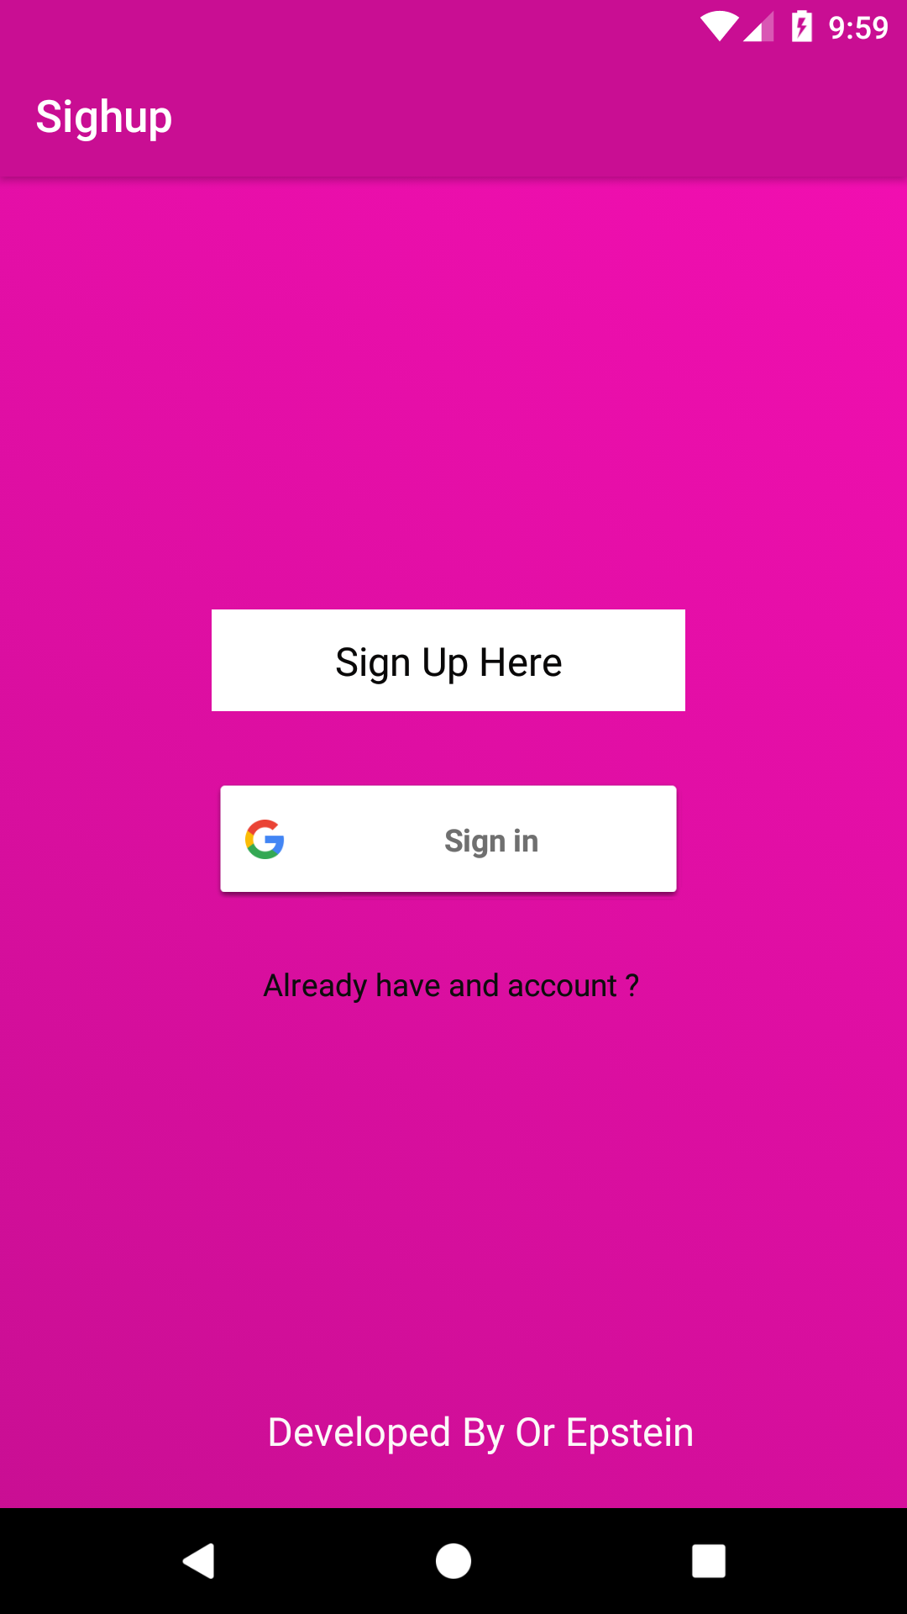  
  
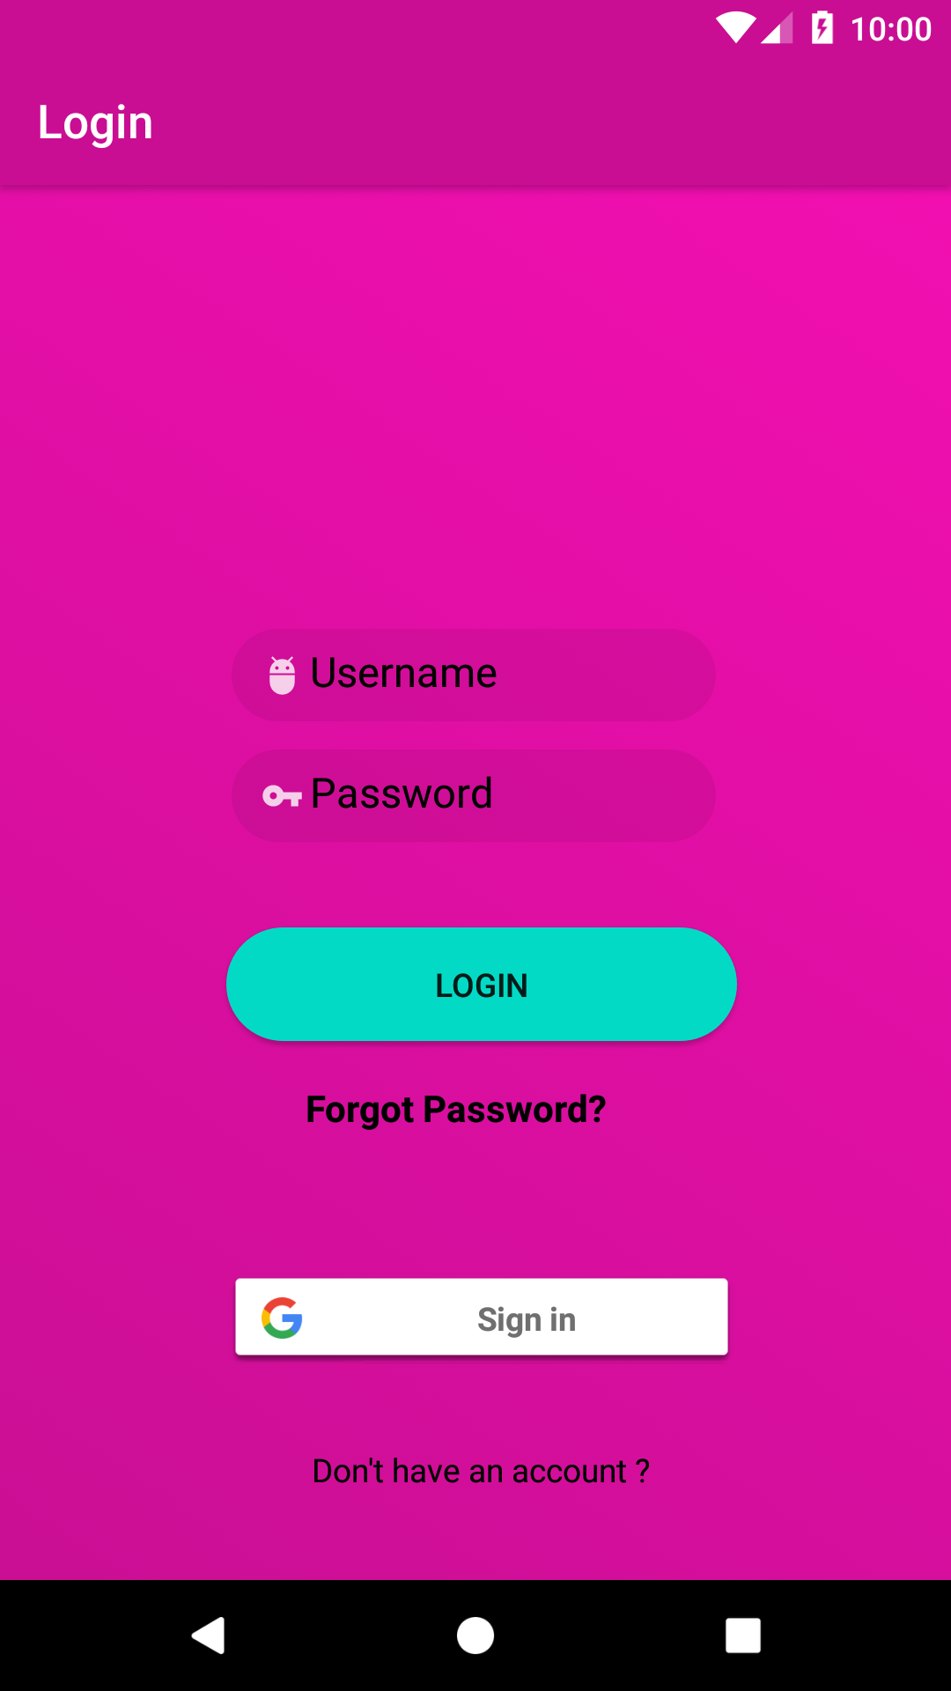  
  
  
  
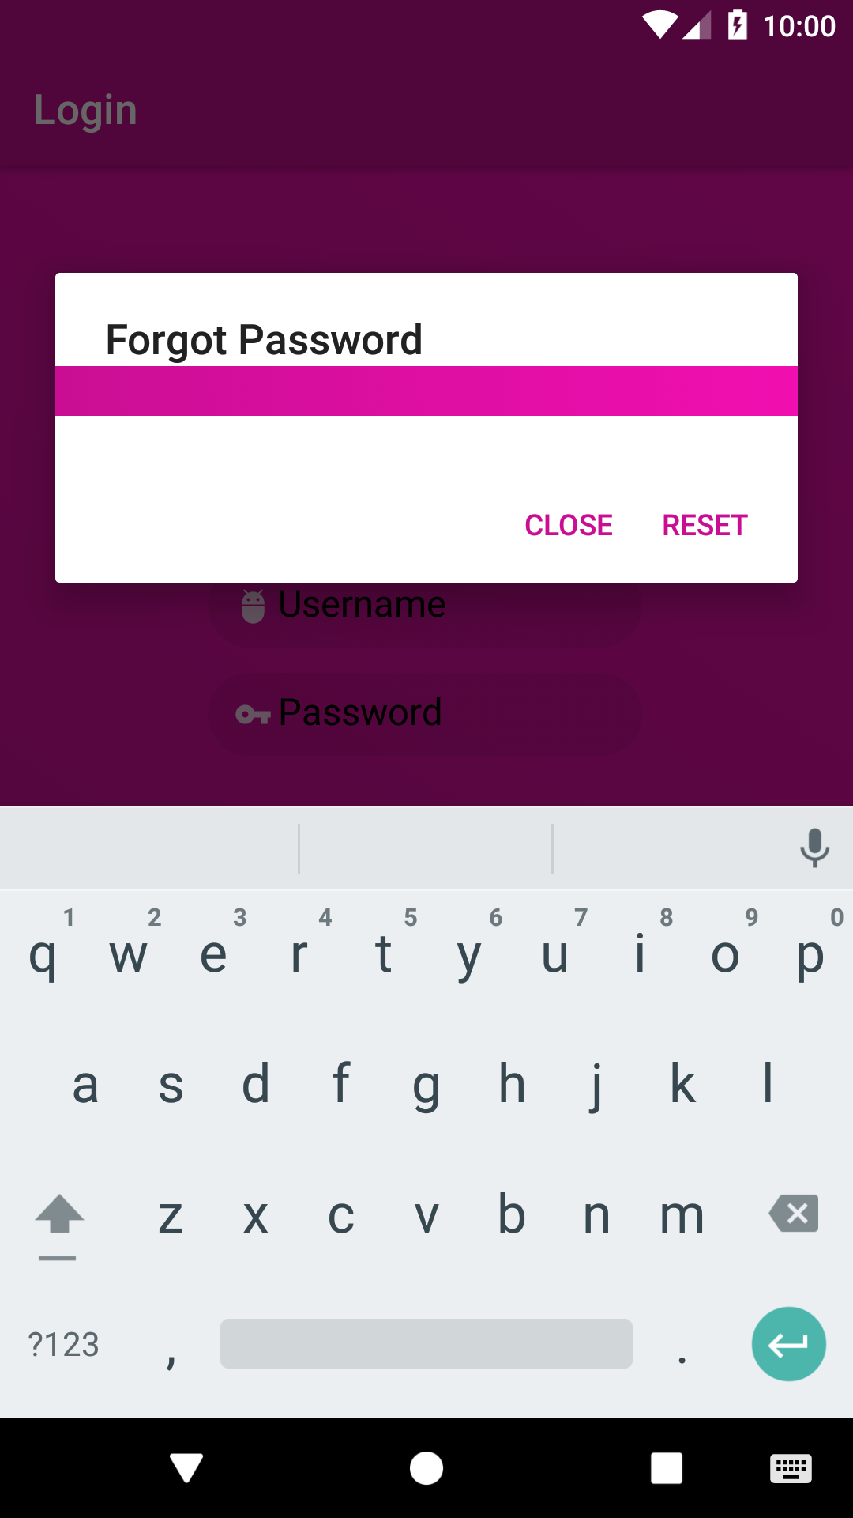  
  
  
  
  
  
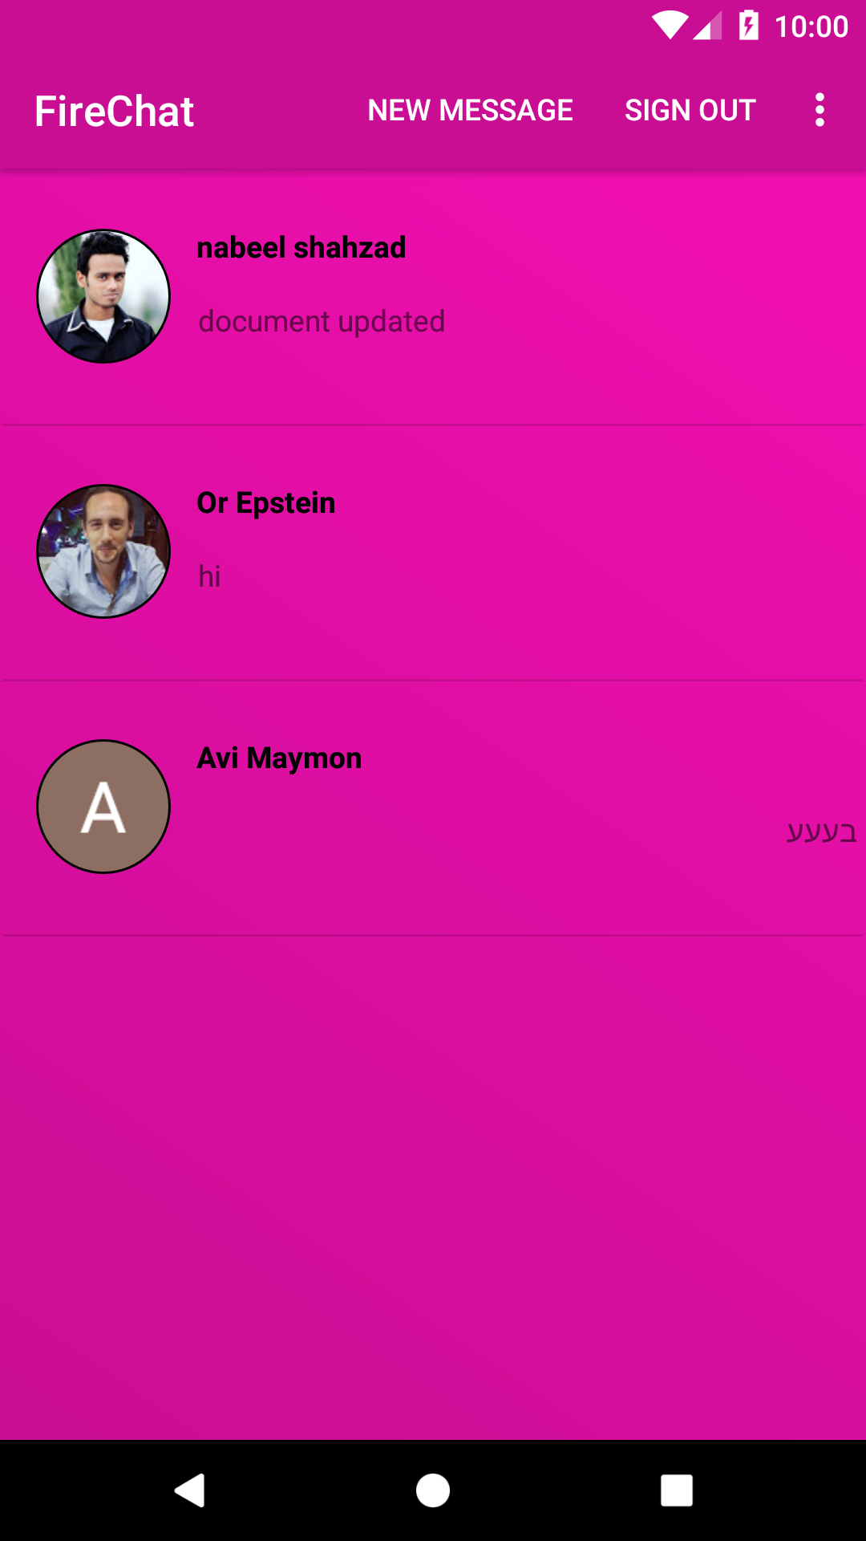  
  
  
  
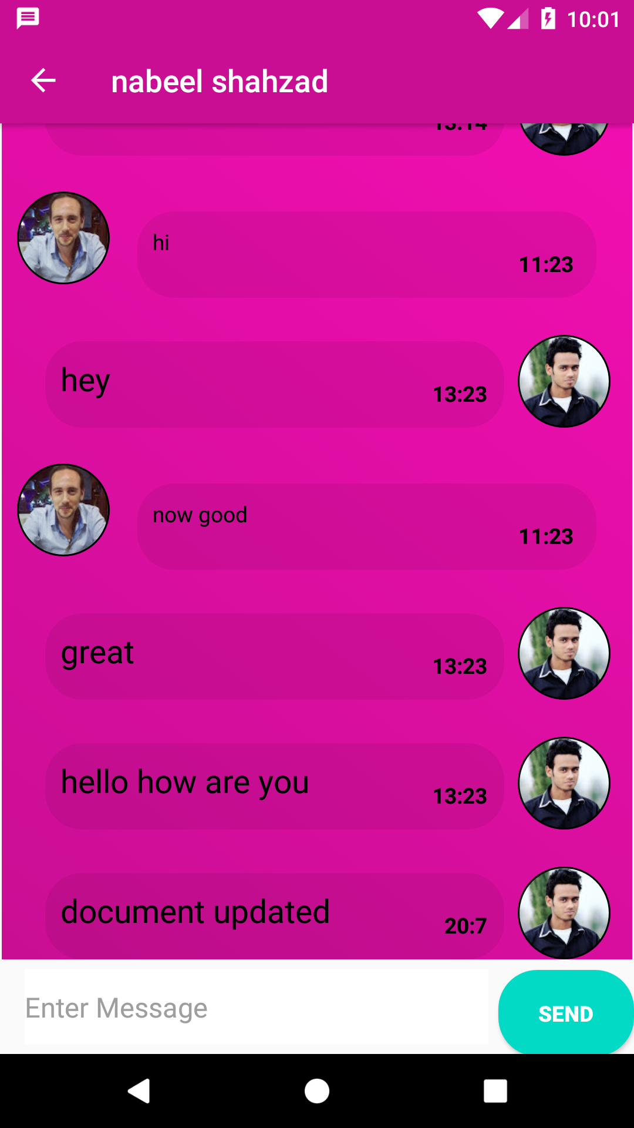  
  
  
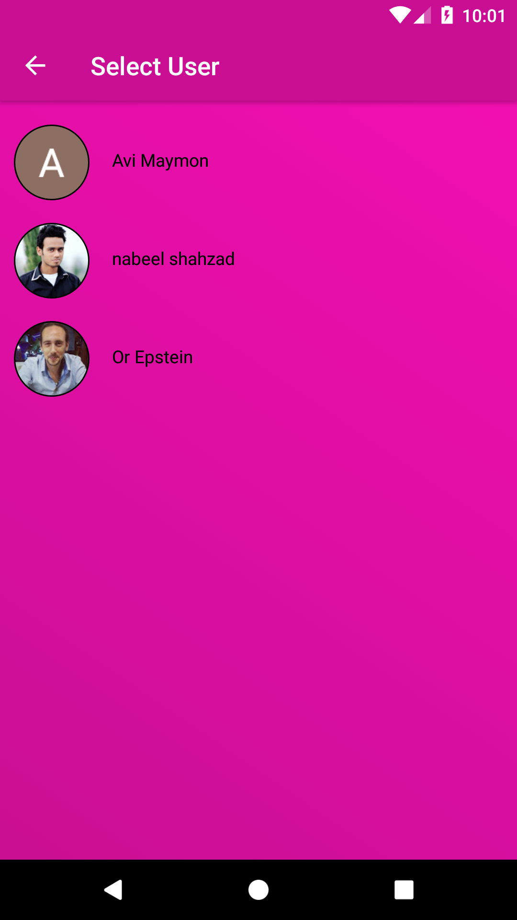  
  
  
  
  
  
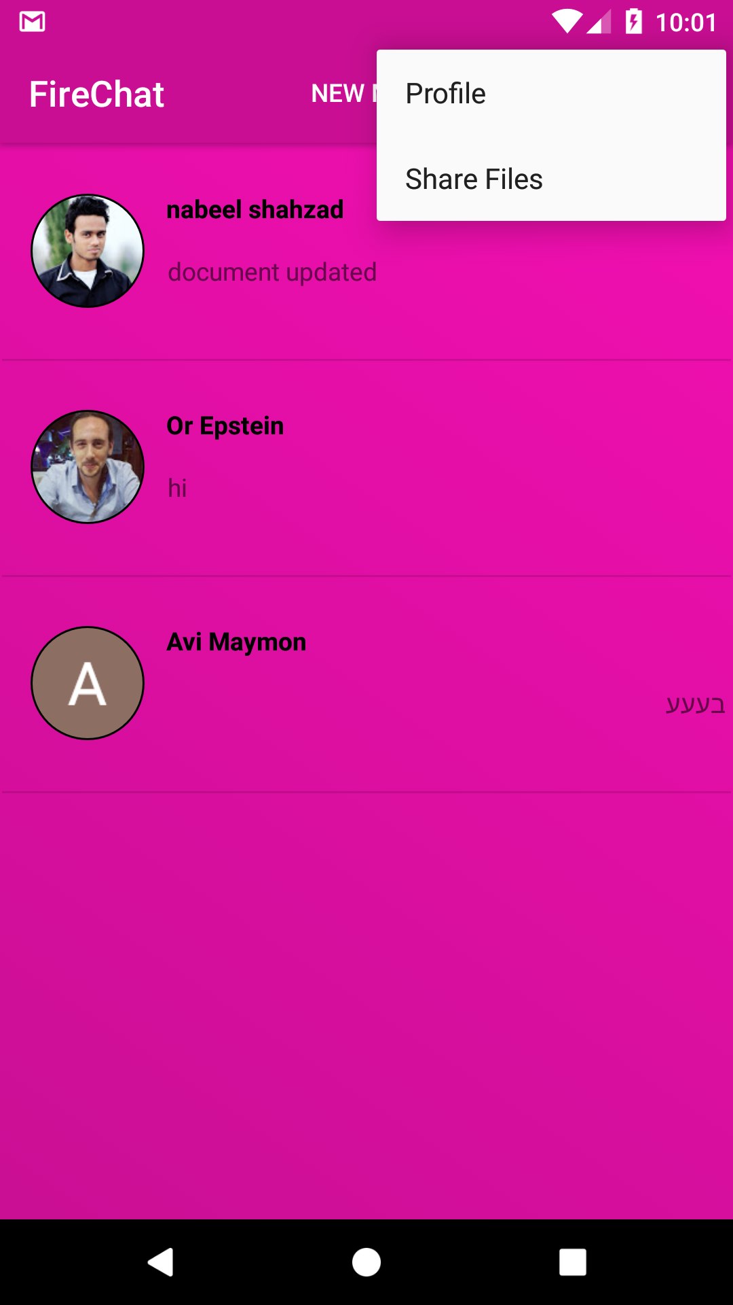  
  
  
  
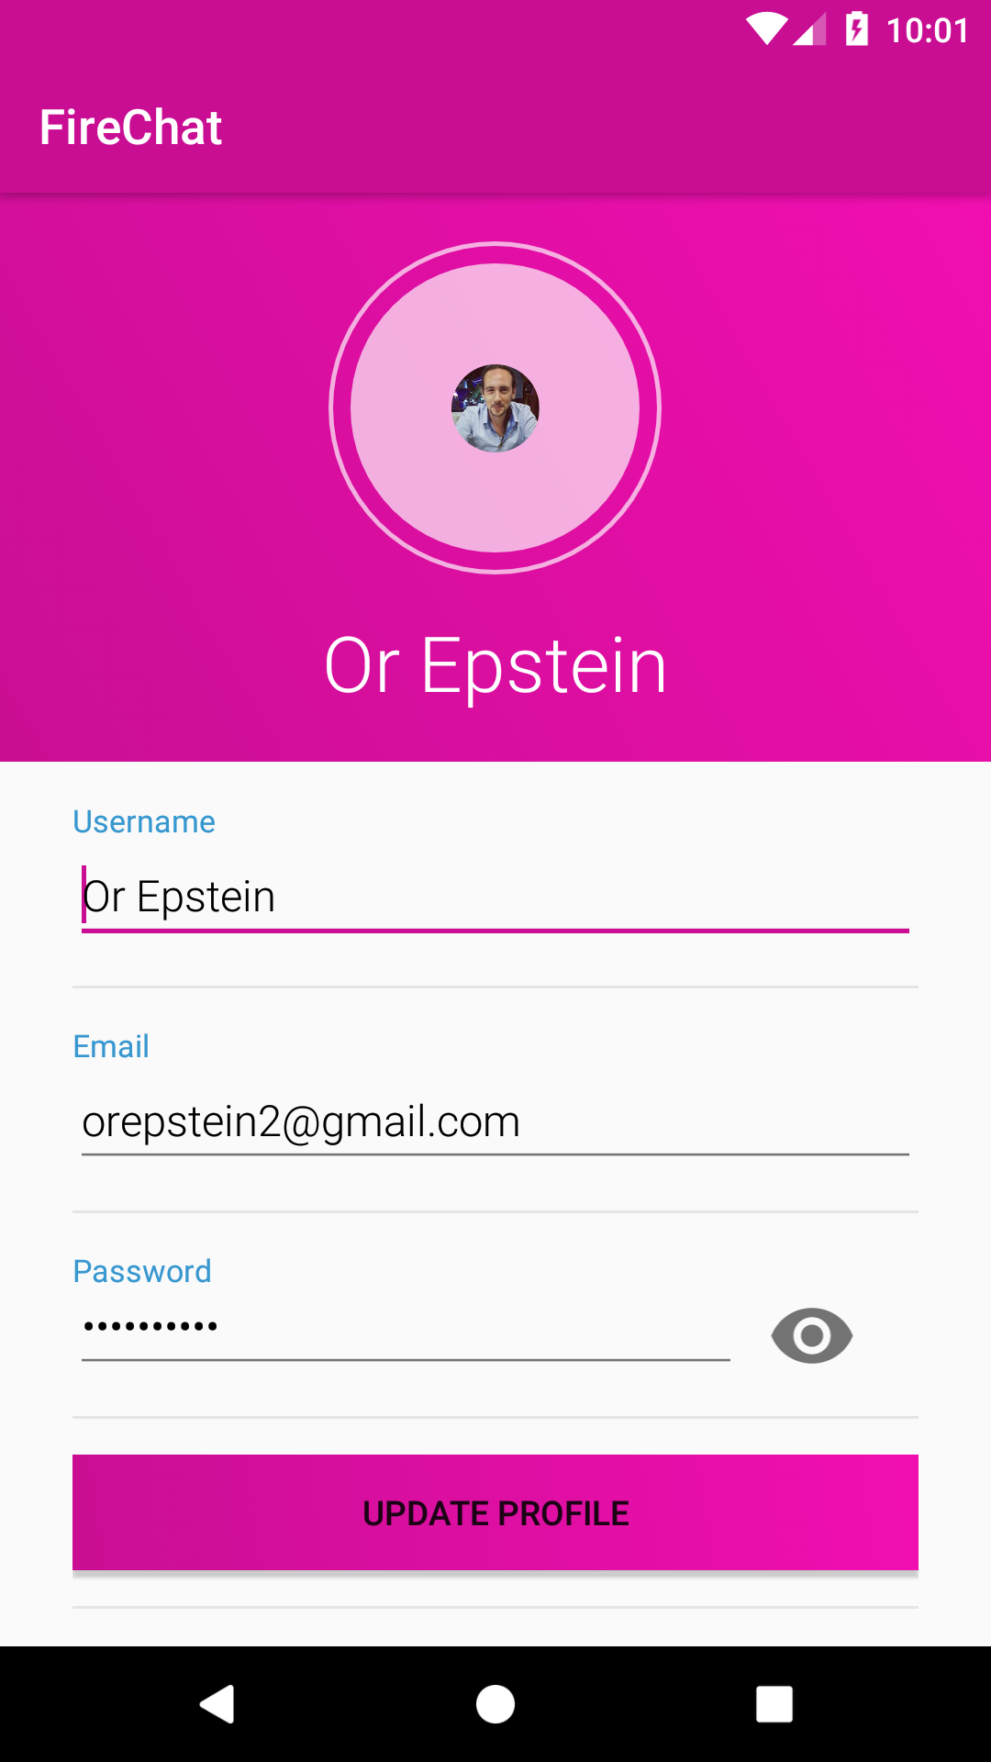  
  
  
  
  
  
  
  
 Type of users:**There is only one type of user.  
Me as a developer is currently the only administrator.

* **How to sign up and login to the app:  
    
  Sign up :**Sign up can be done by clicking one button via his google account to a super fast sign up.

**Login:**Login can be done in the same way using google.

**Key system charts:  
  
Use case  
  
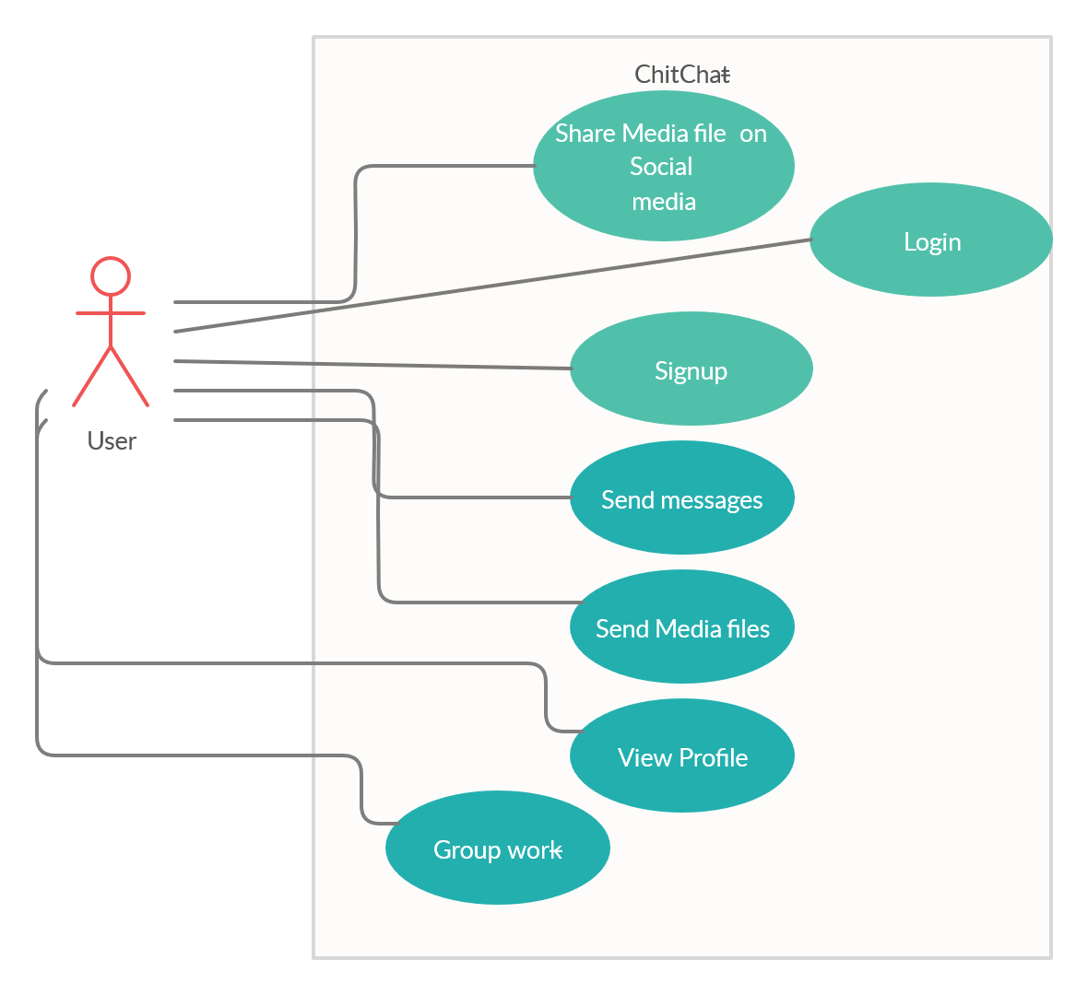  
  
**

**Folder structure  
  
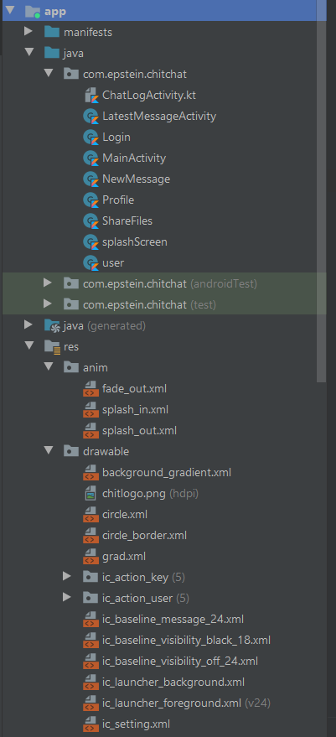**  
  
  
  
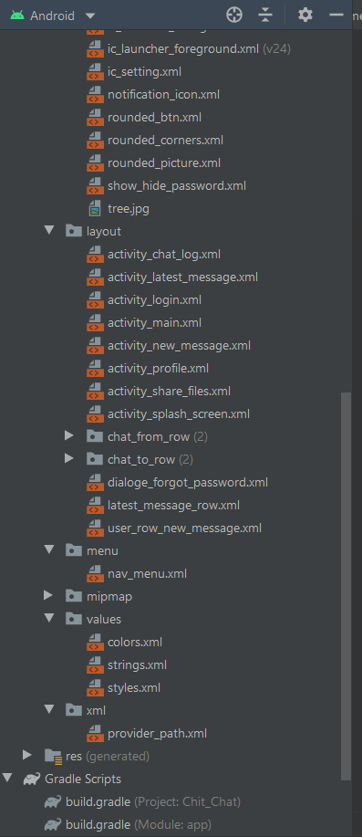  
  
  
  
  
  
  
  
  
**Structure and detail of user database  
  
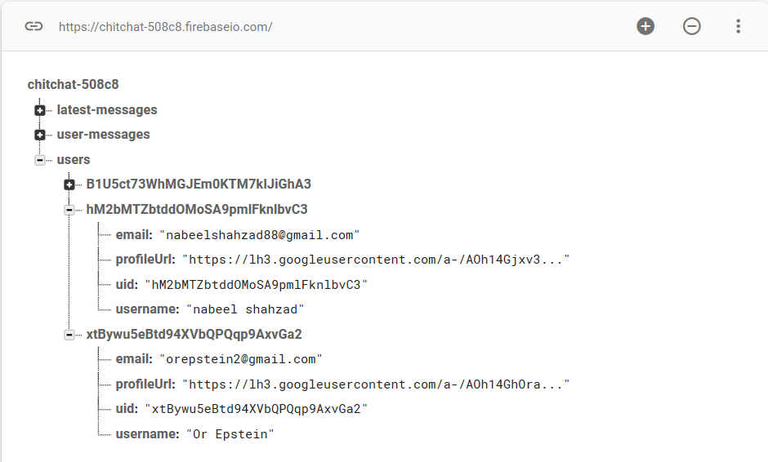**  
**Structure and detail of users  
  
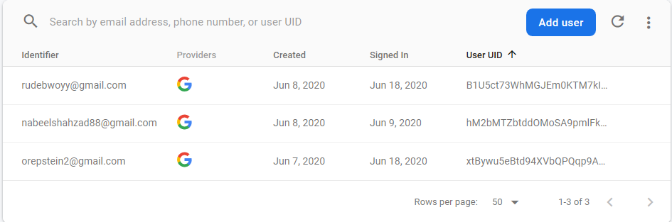**

**Database structure**  
  
  
  
  
  
  
  
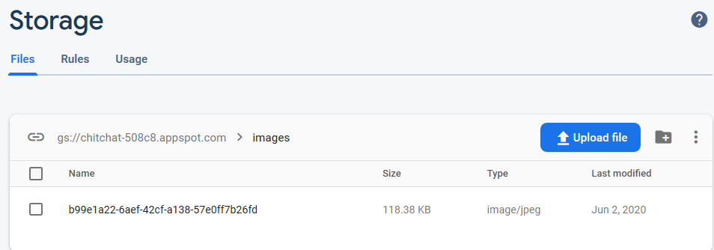  
  
  
  
**Chapter C: Project Code**  
Splash screen  
 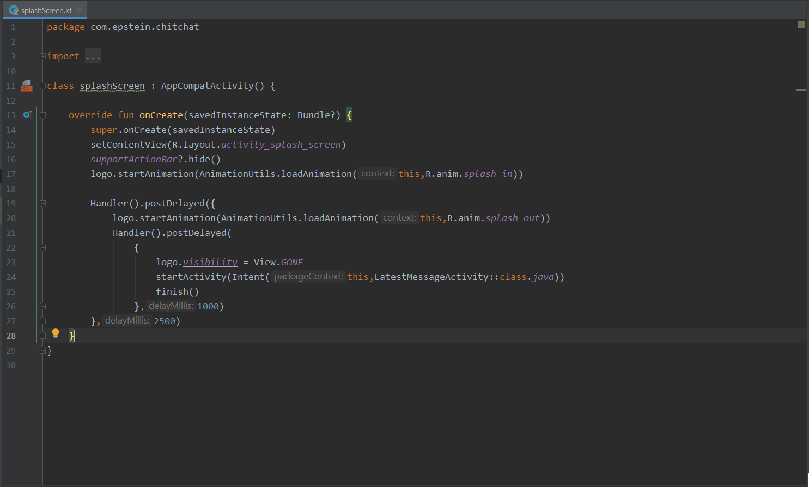

Main activity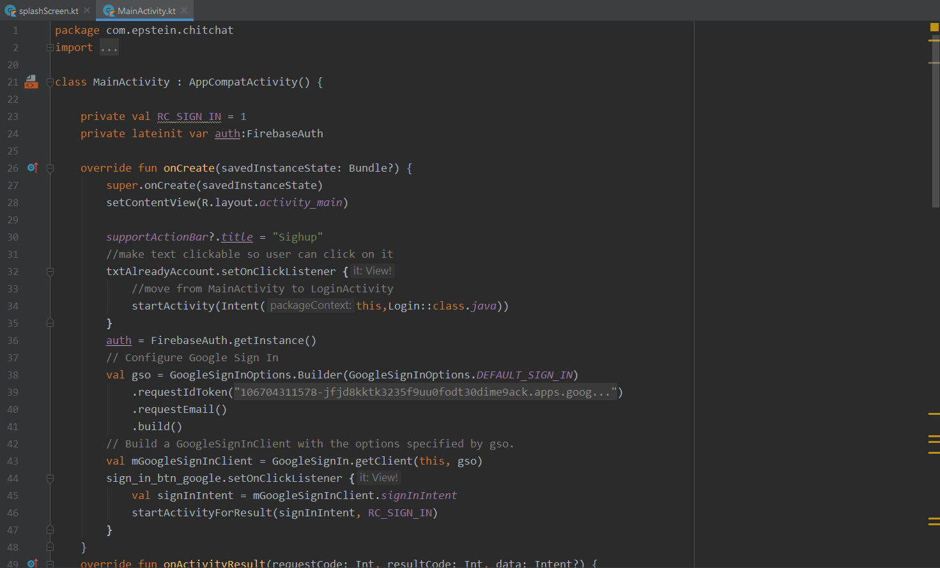  
  
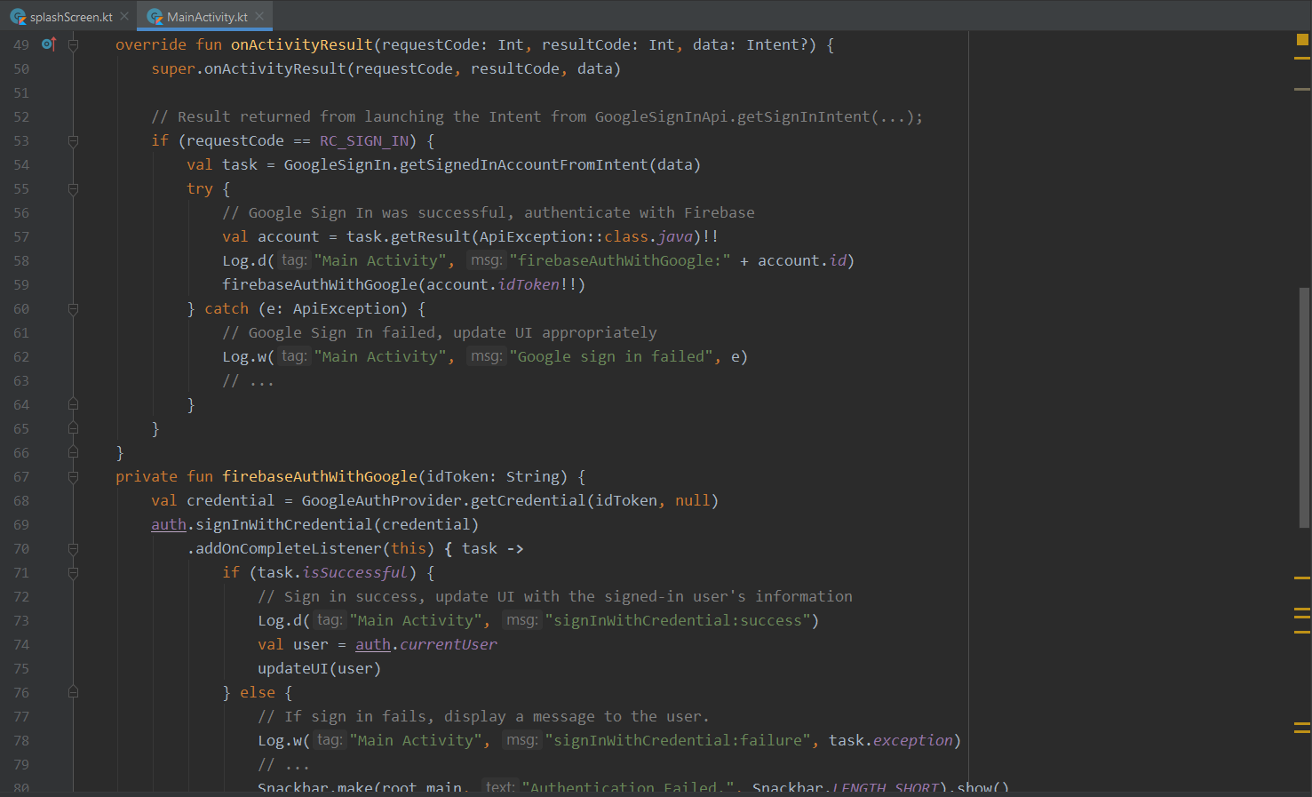  
  
  
  
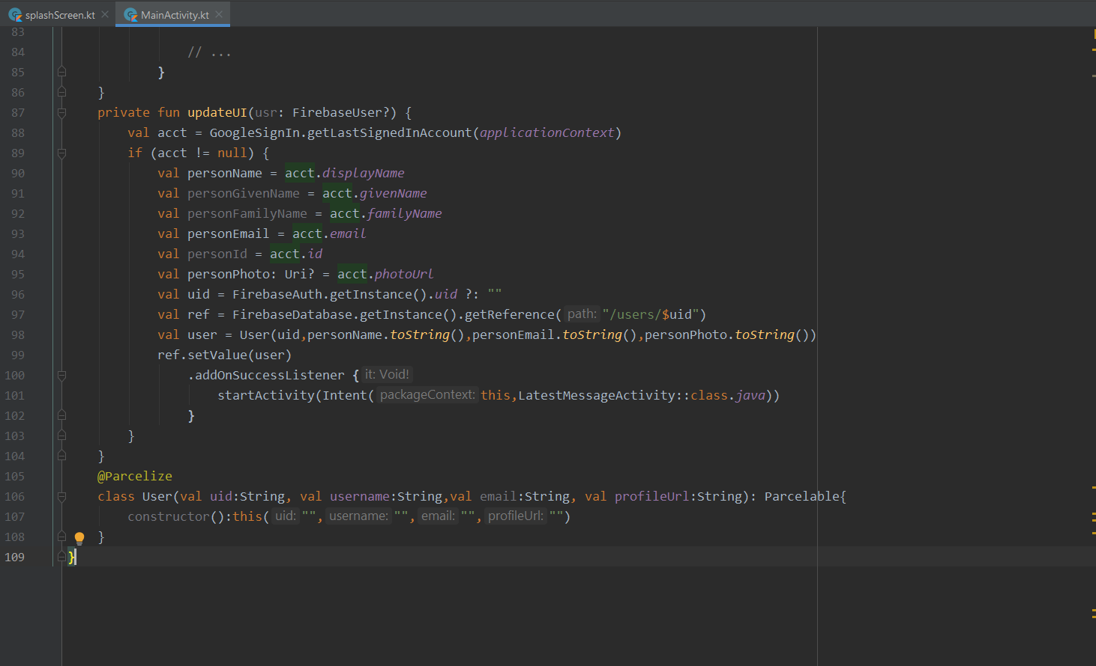  
  
  
  
  
  
  
  
  
  
  
  
  
  
  
  
  
  
  
  
  
login  
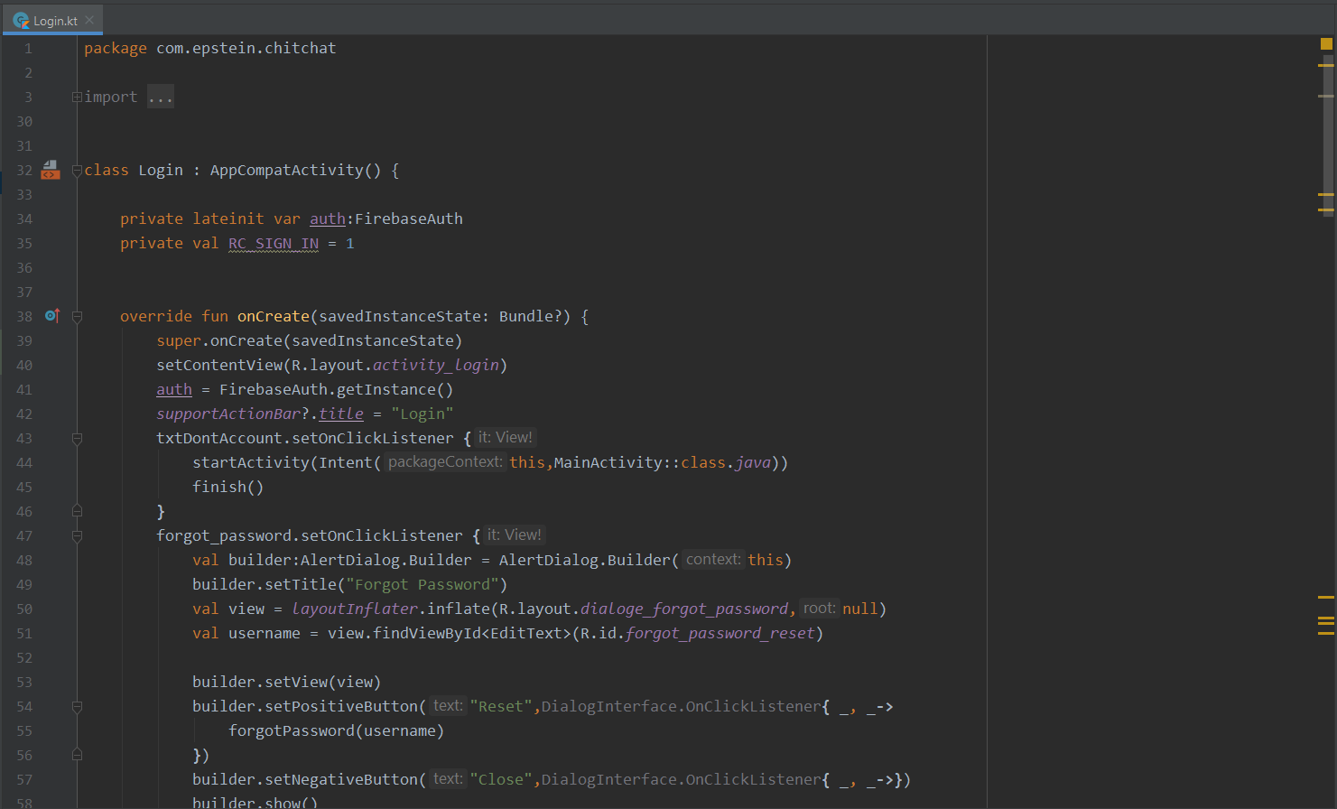  
  
  
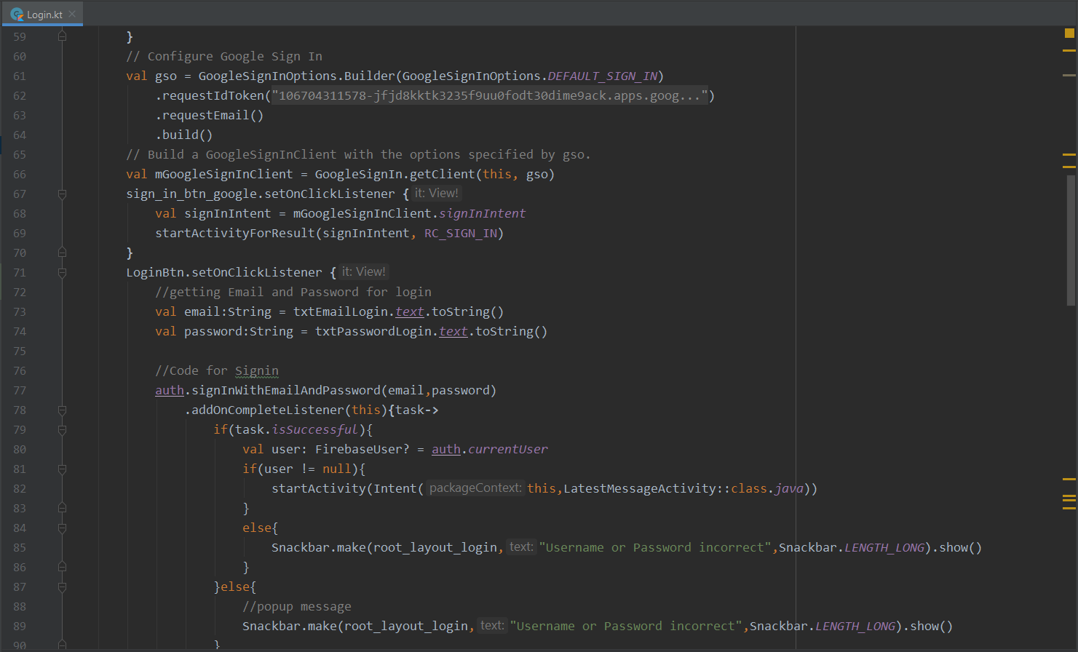  
  
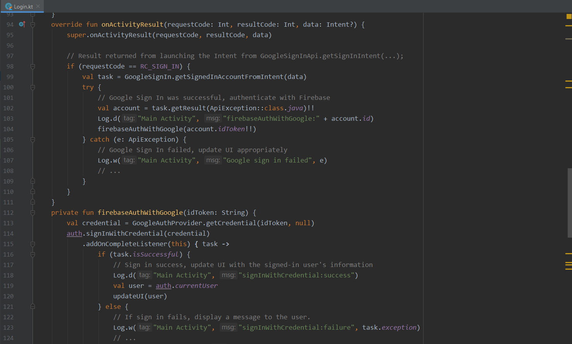  
  
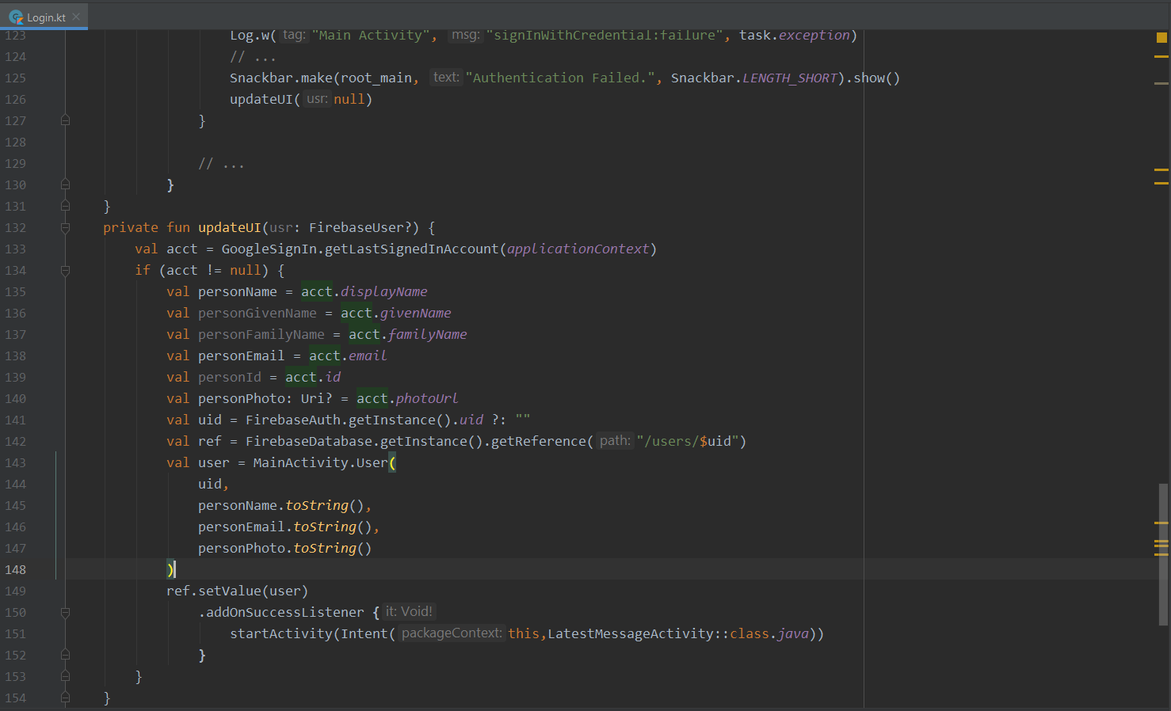  
  
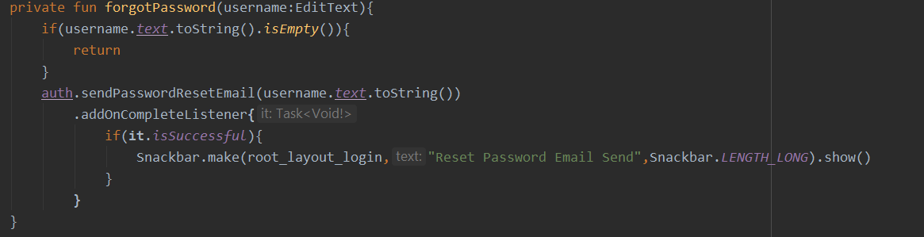  
Chat log  
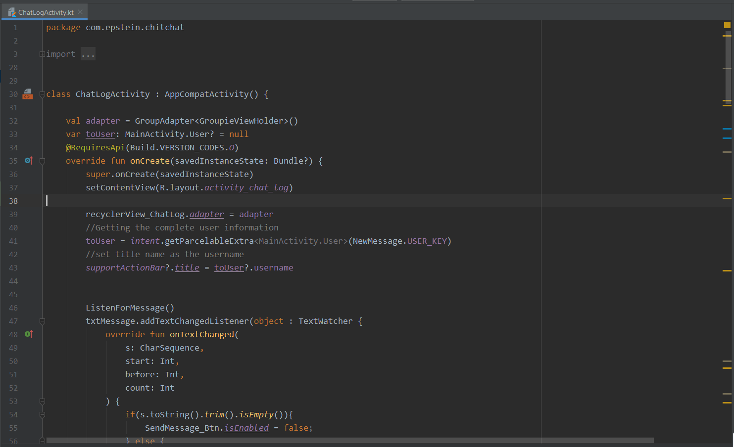  
  
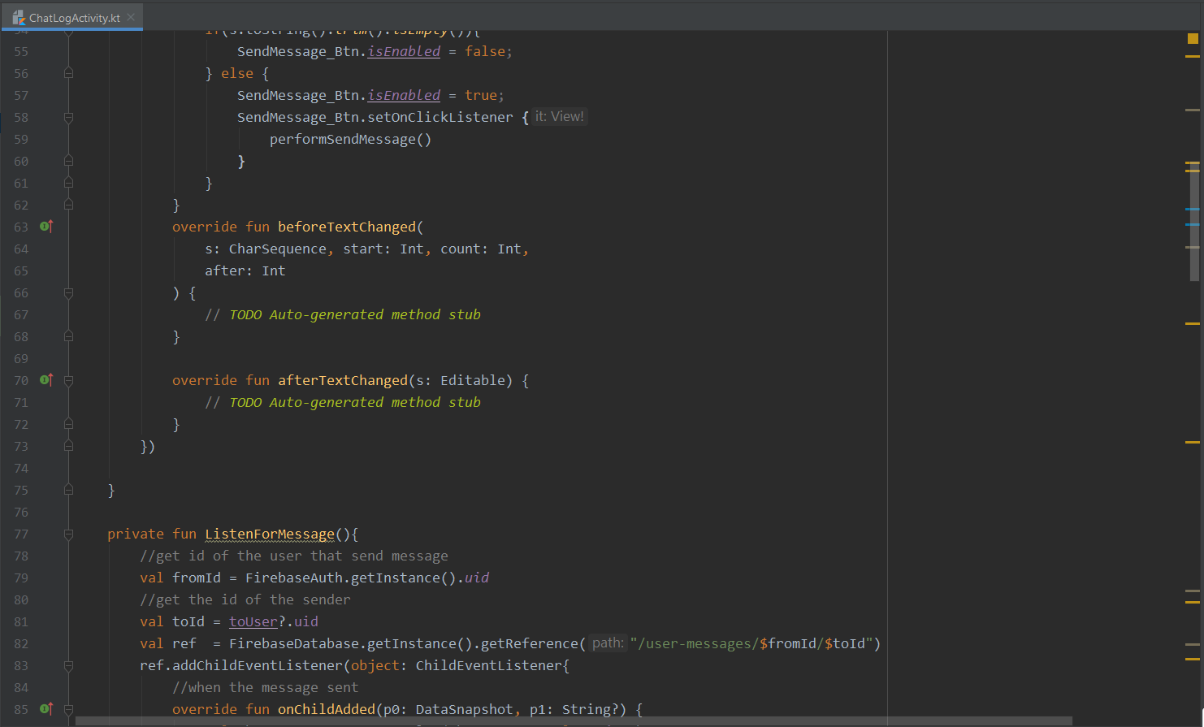  
  
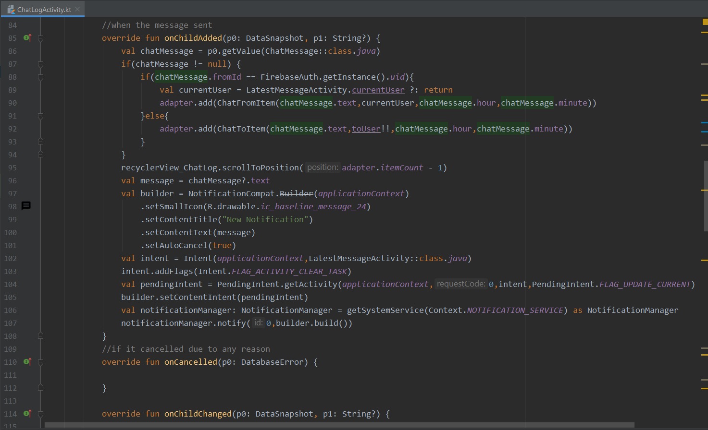  
  
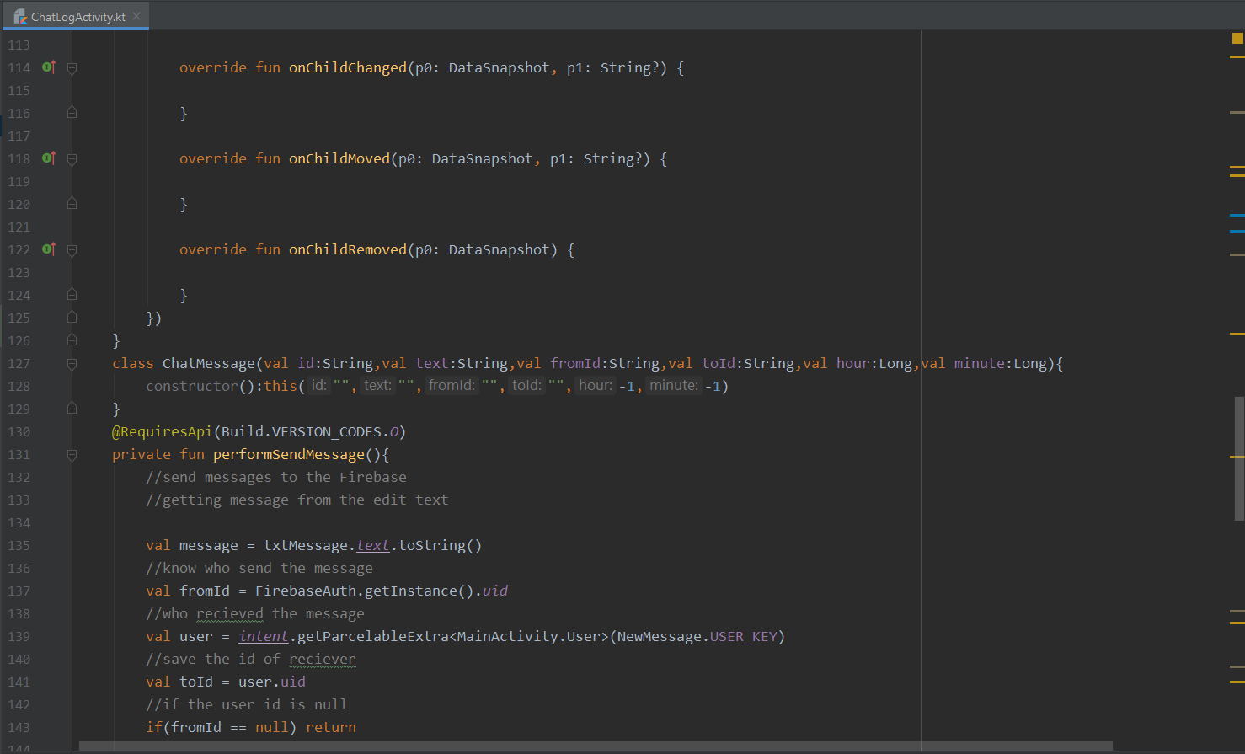  
  
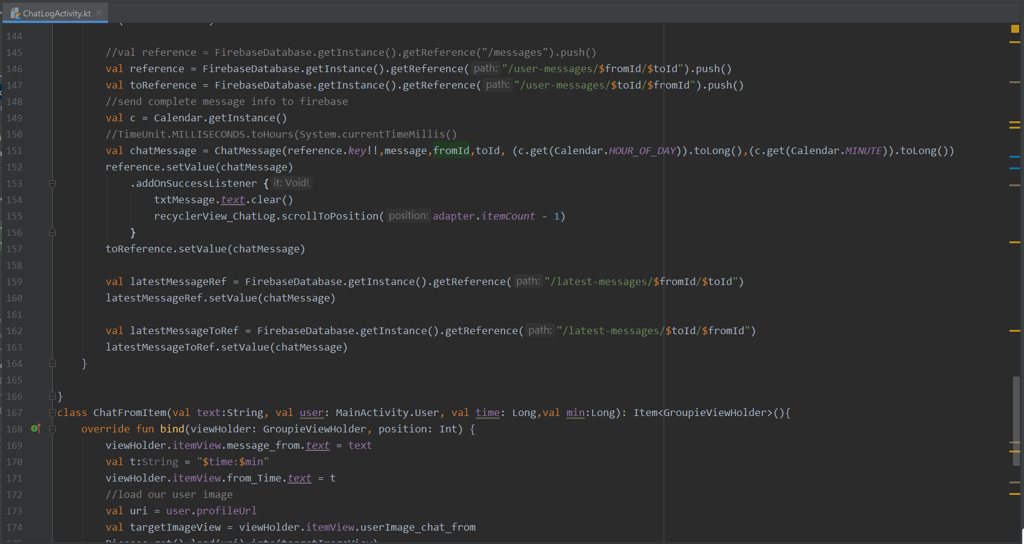  
  
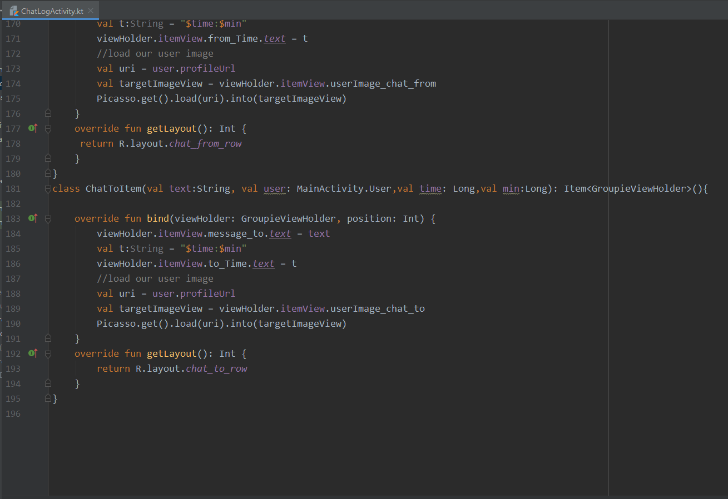  
  
  
Latest message  
 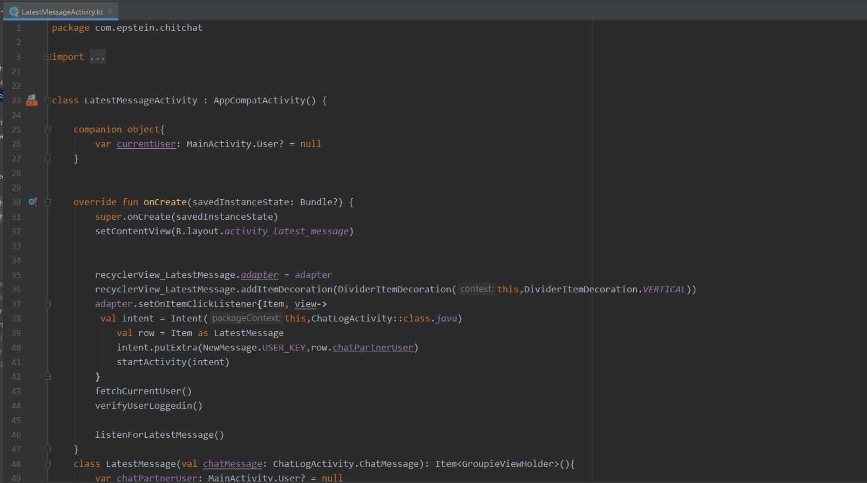  
  
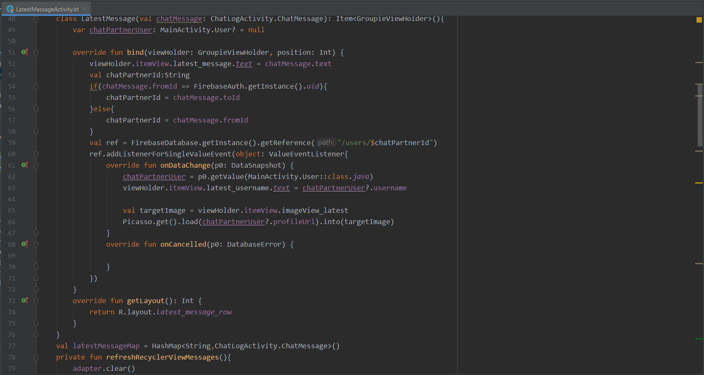  
  
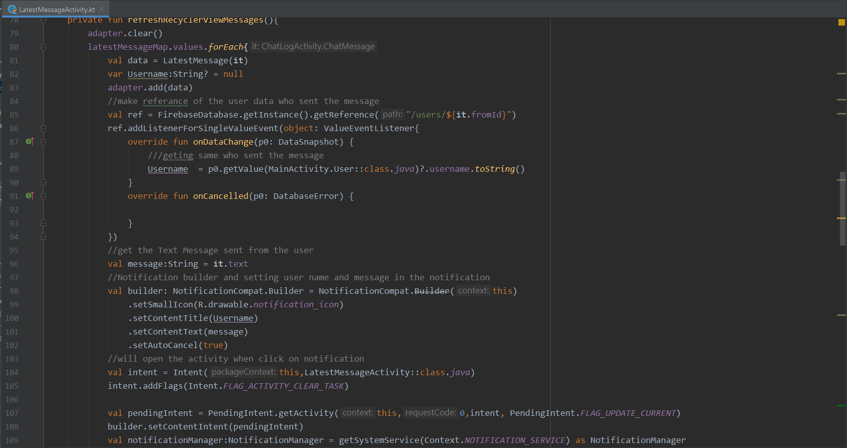  
  
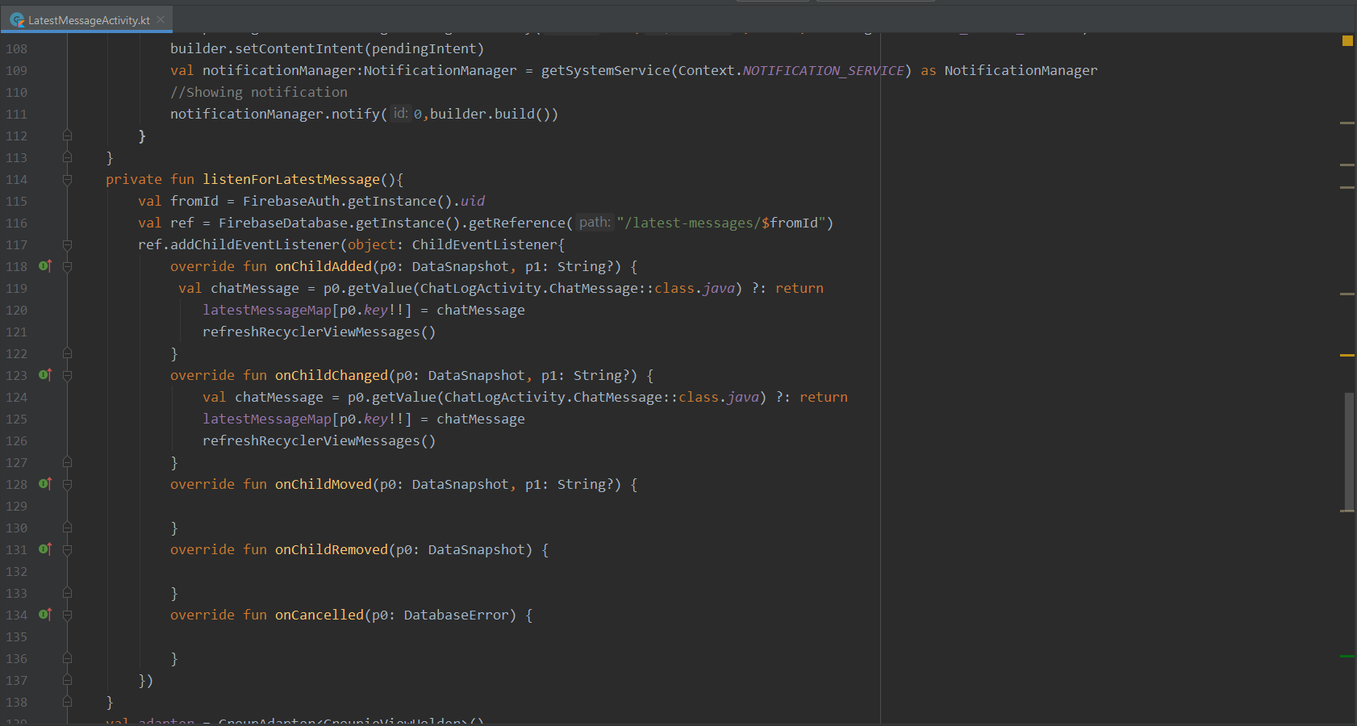  
  
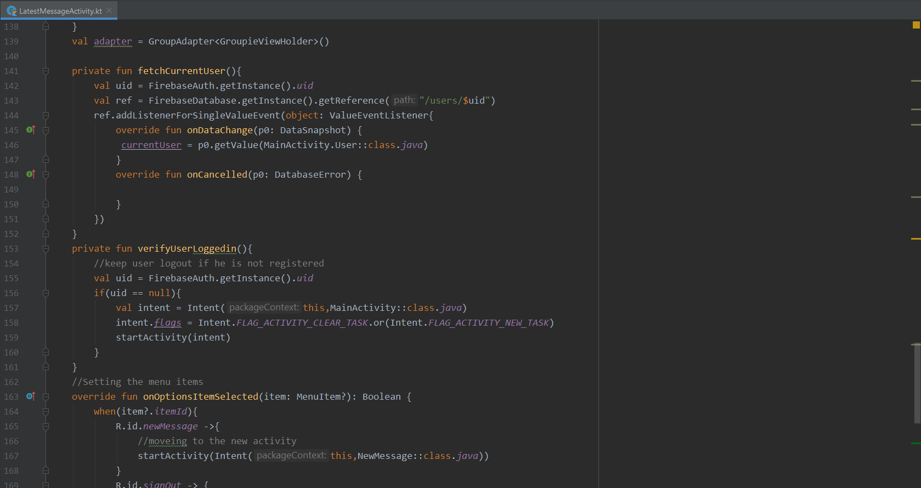  
  
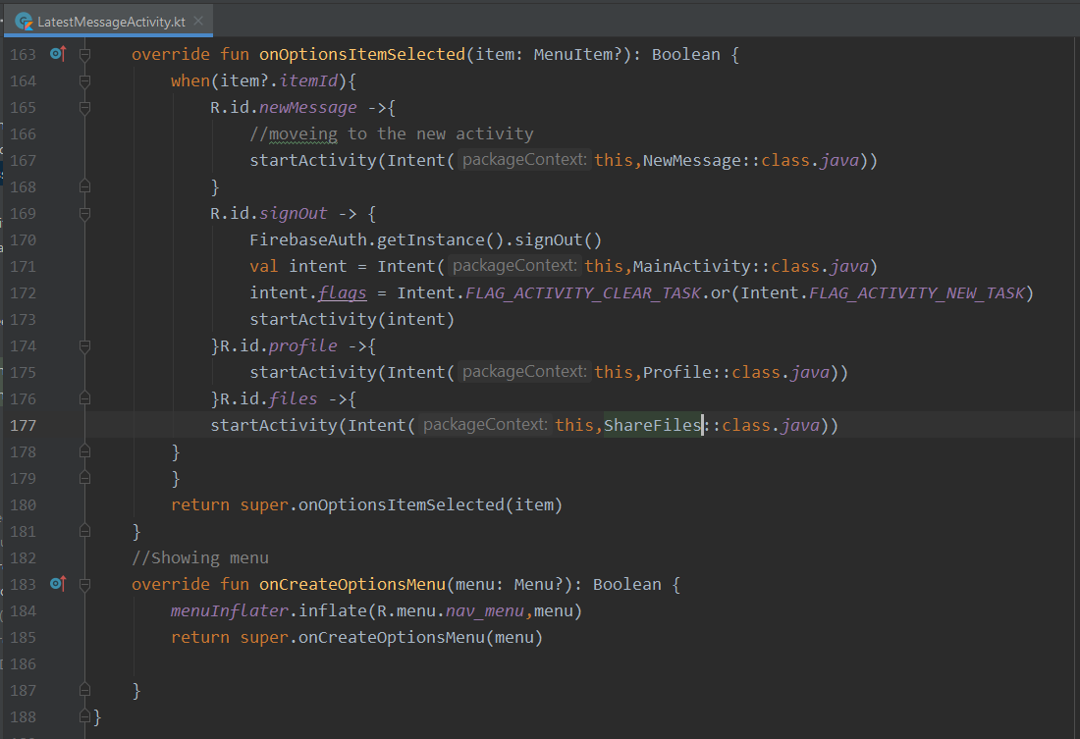  
  
  
  
New massage  
  
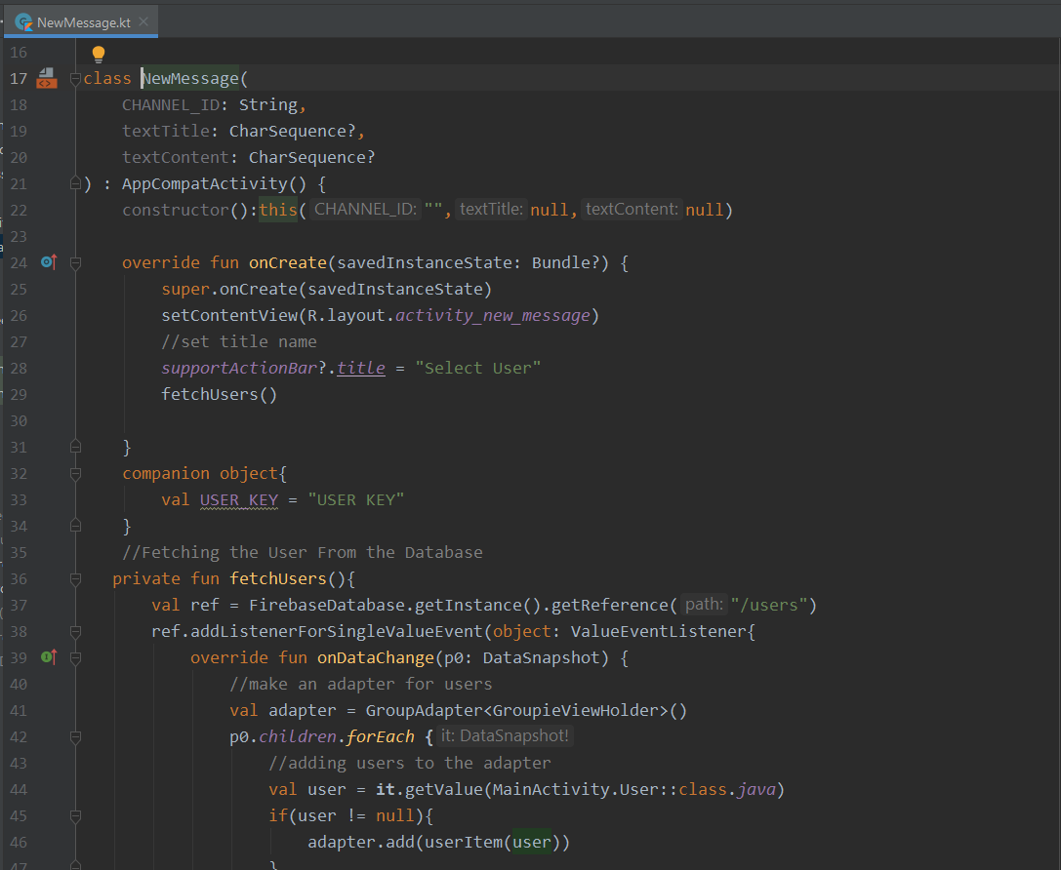  
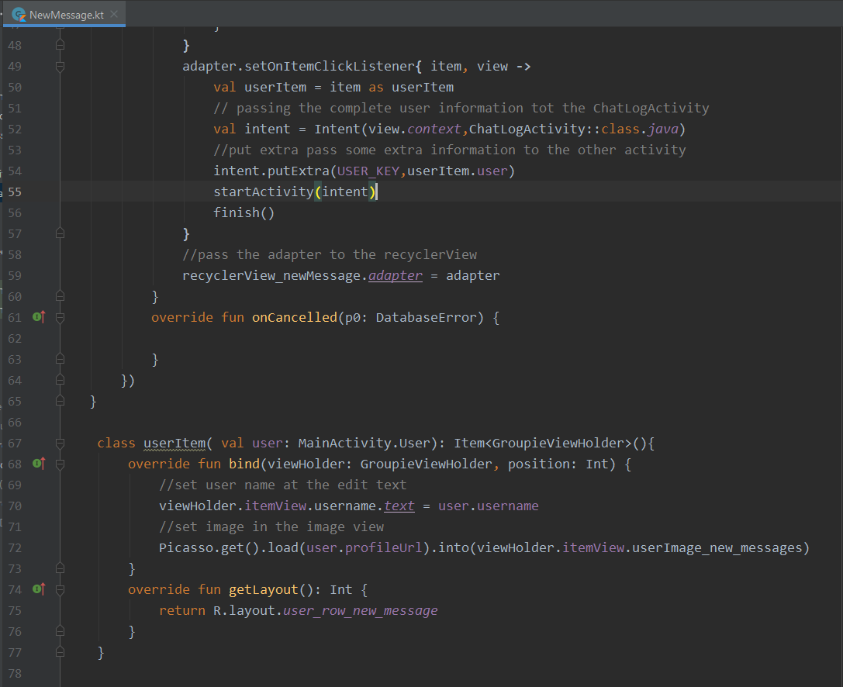  
profile  
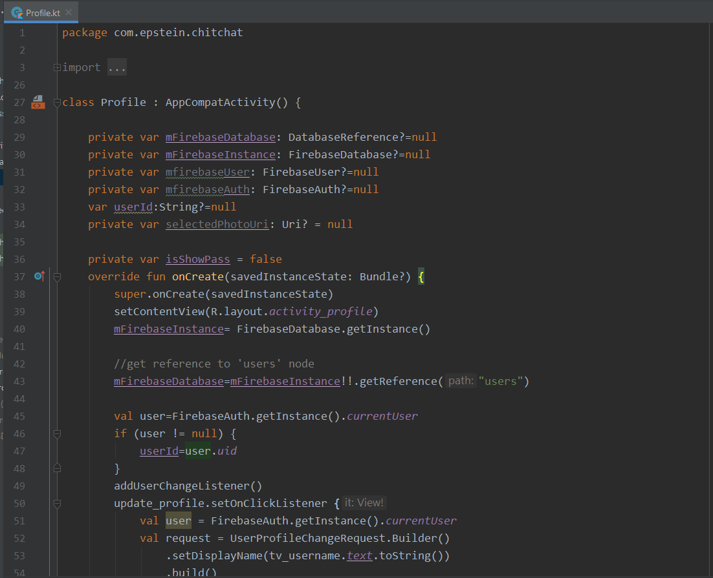  
  
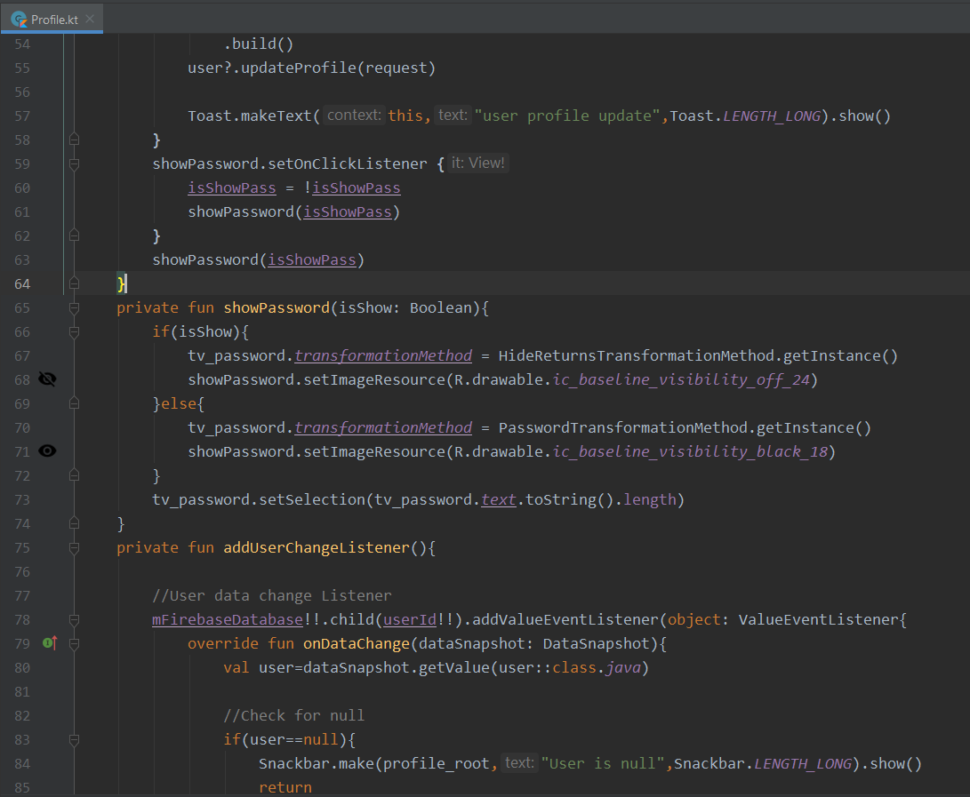  
  
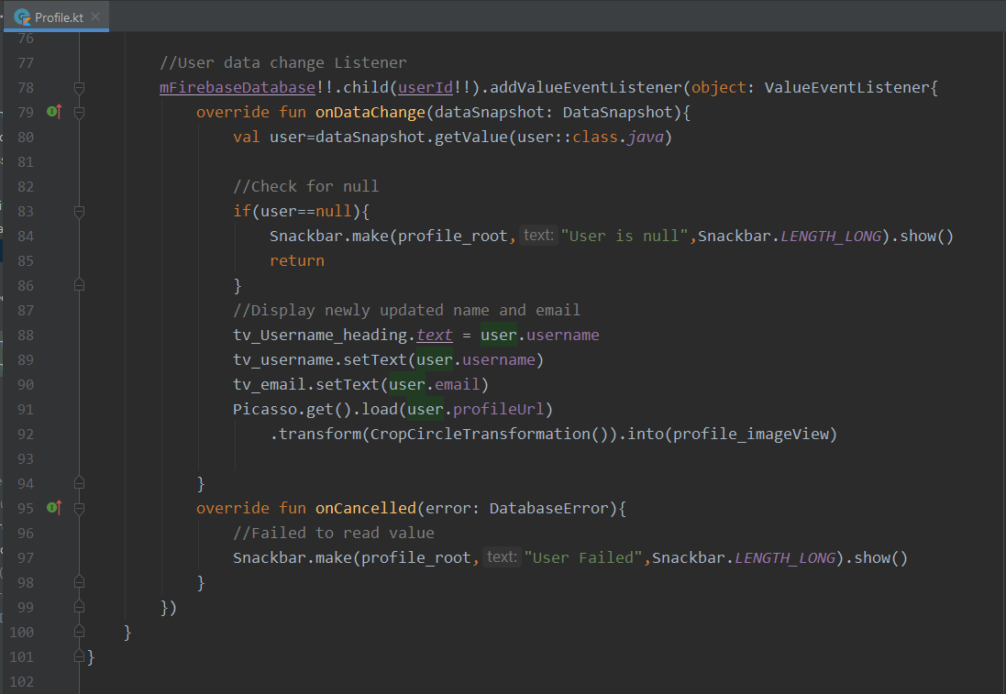  
  
Share files  
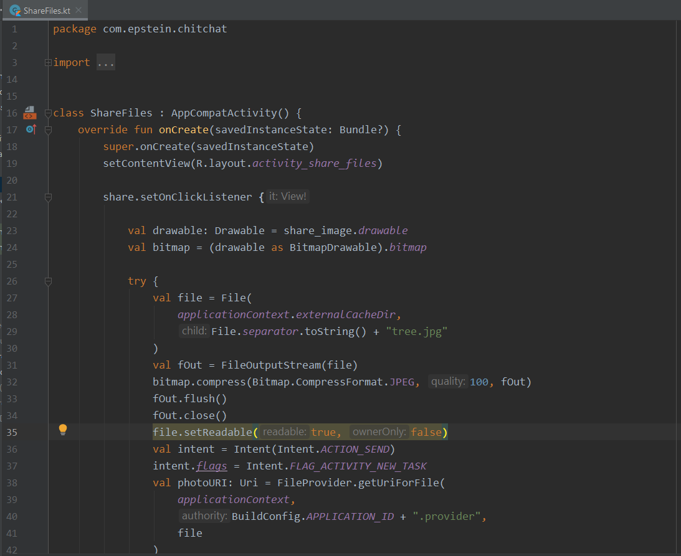  
  
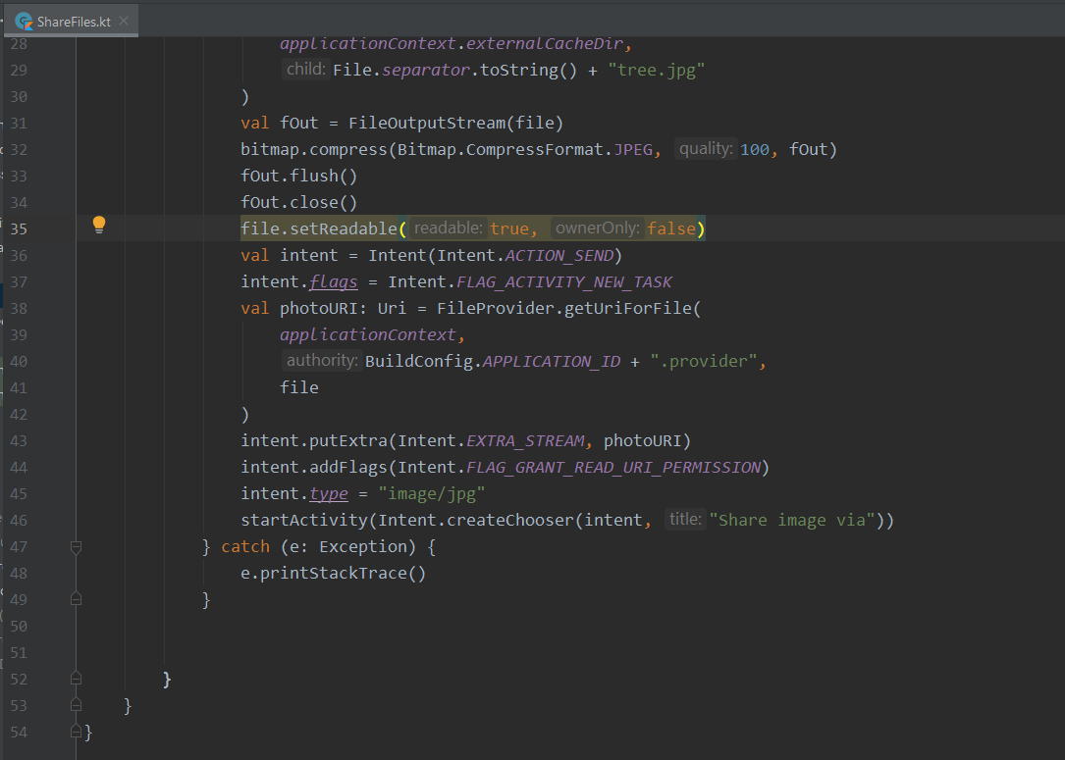  
  
Users  
  
  
  
  
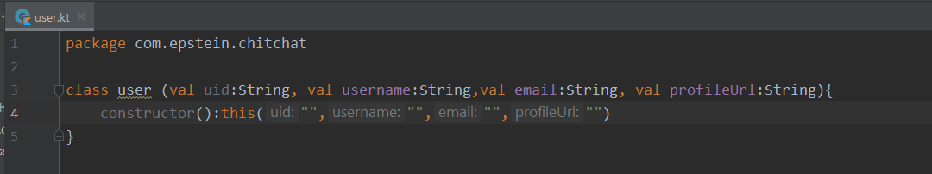  
  
  
  
  
**Xml images :**  
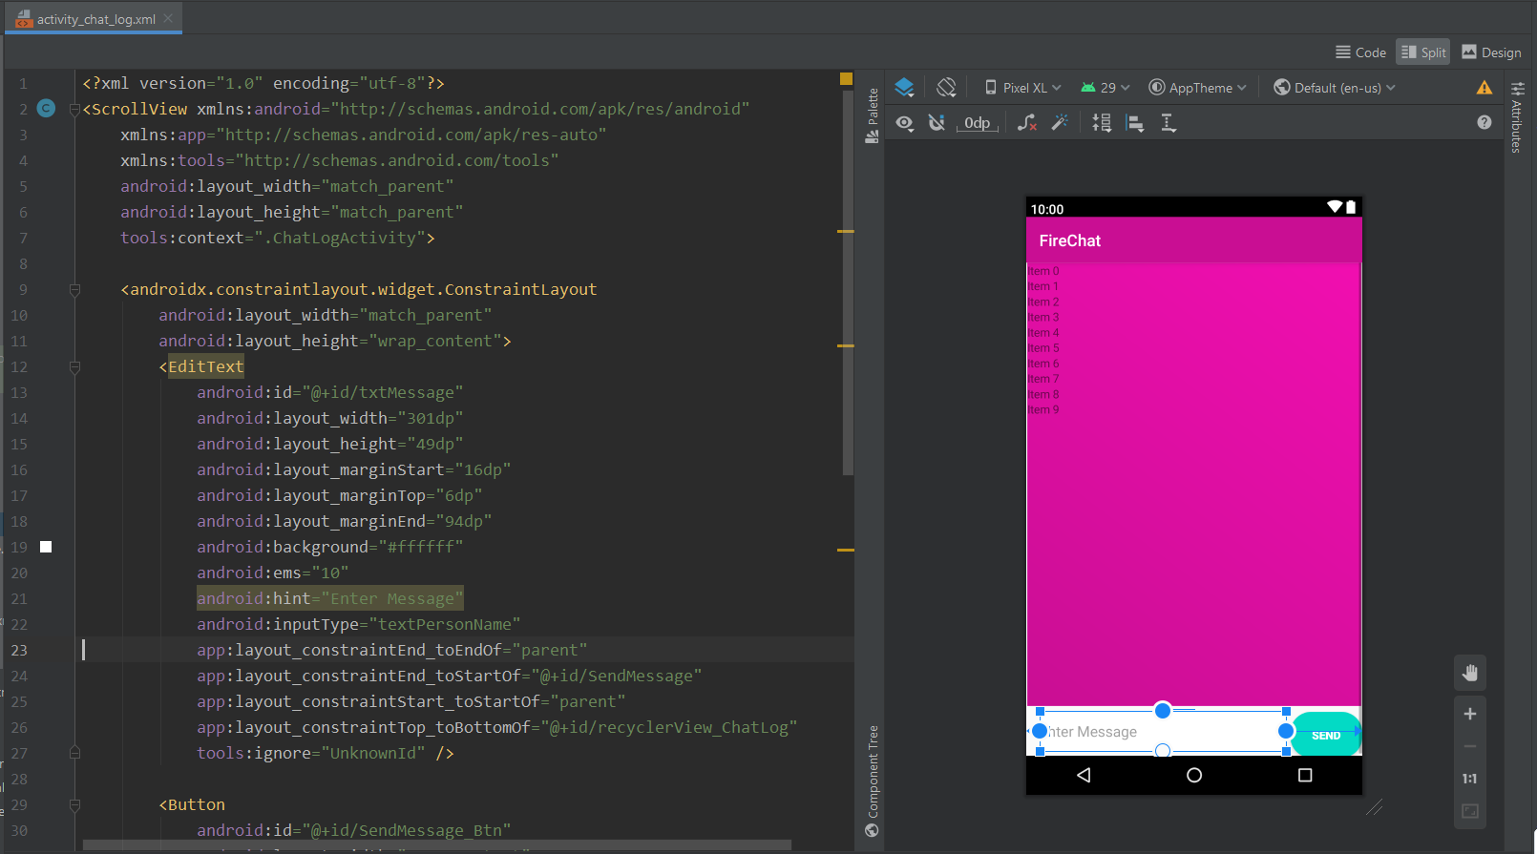  
  
  
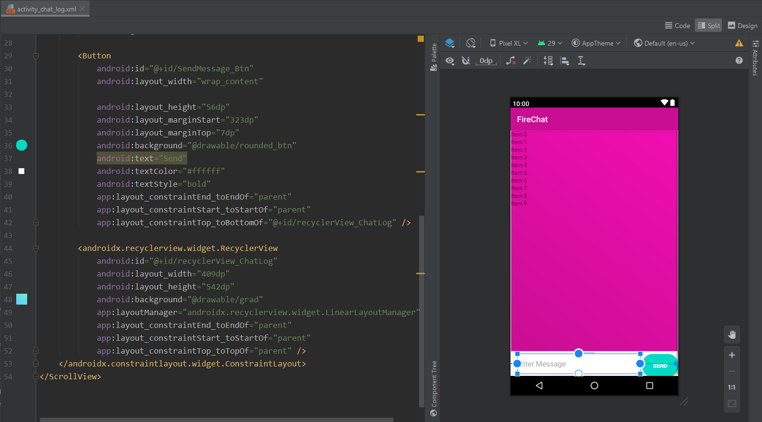  
  
latest_massage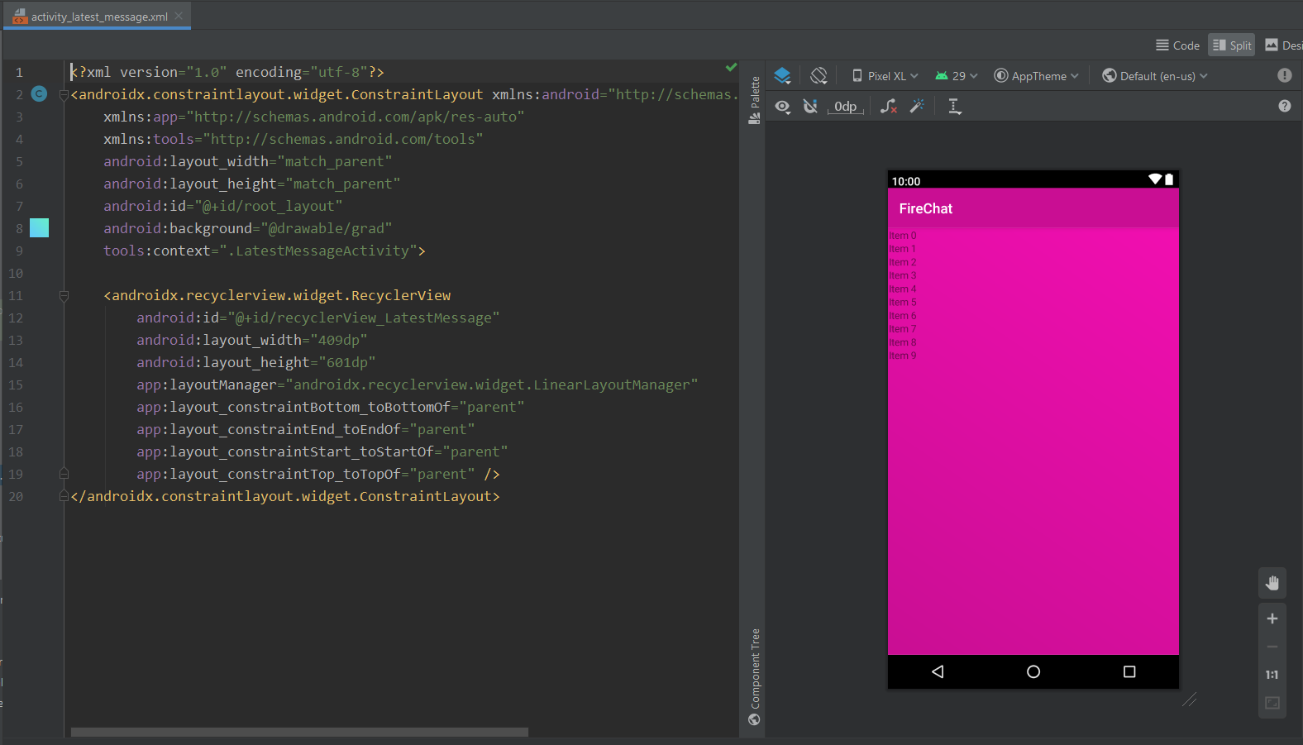  
  
  
  
Login xml  
  
  
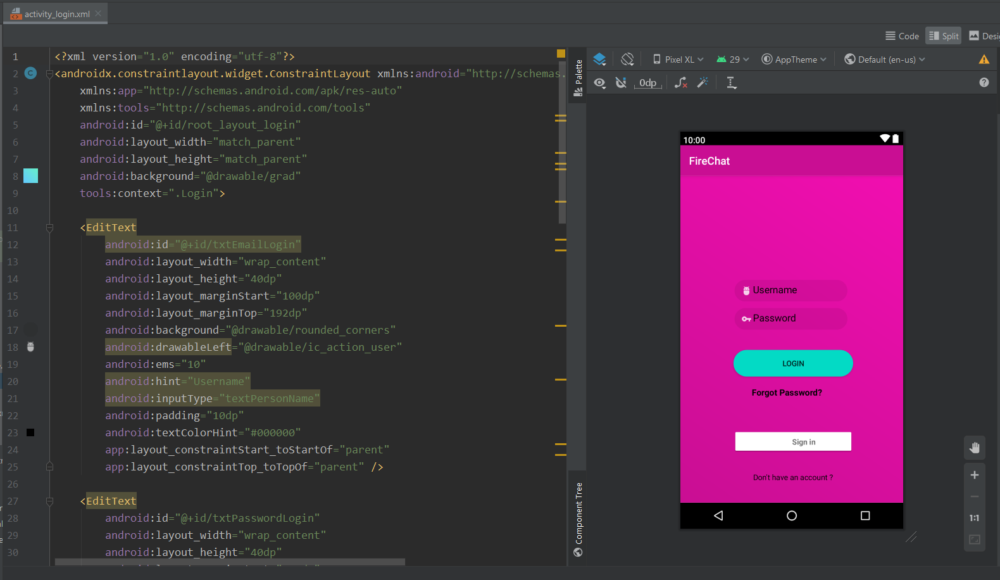  
  
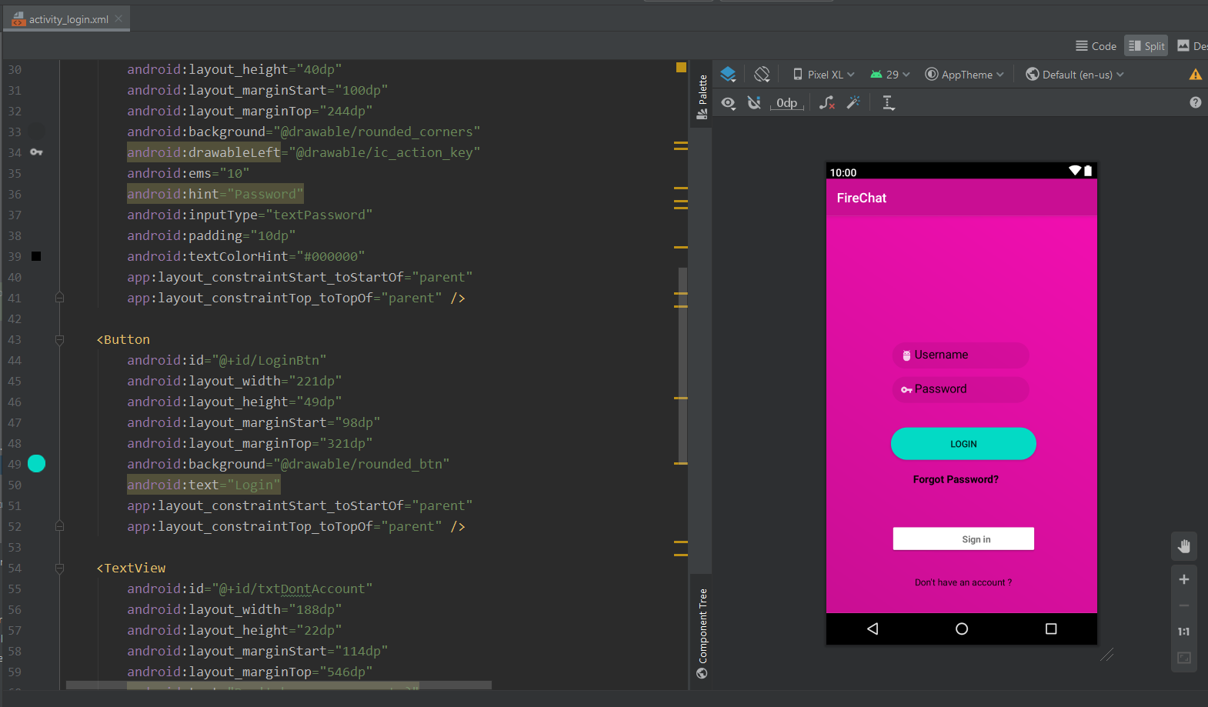  
  
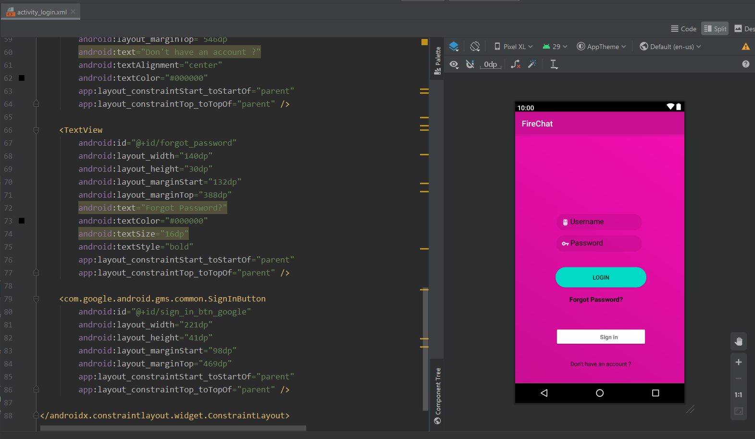  
  
Main activity  
  
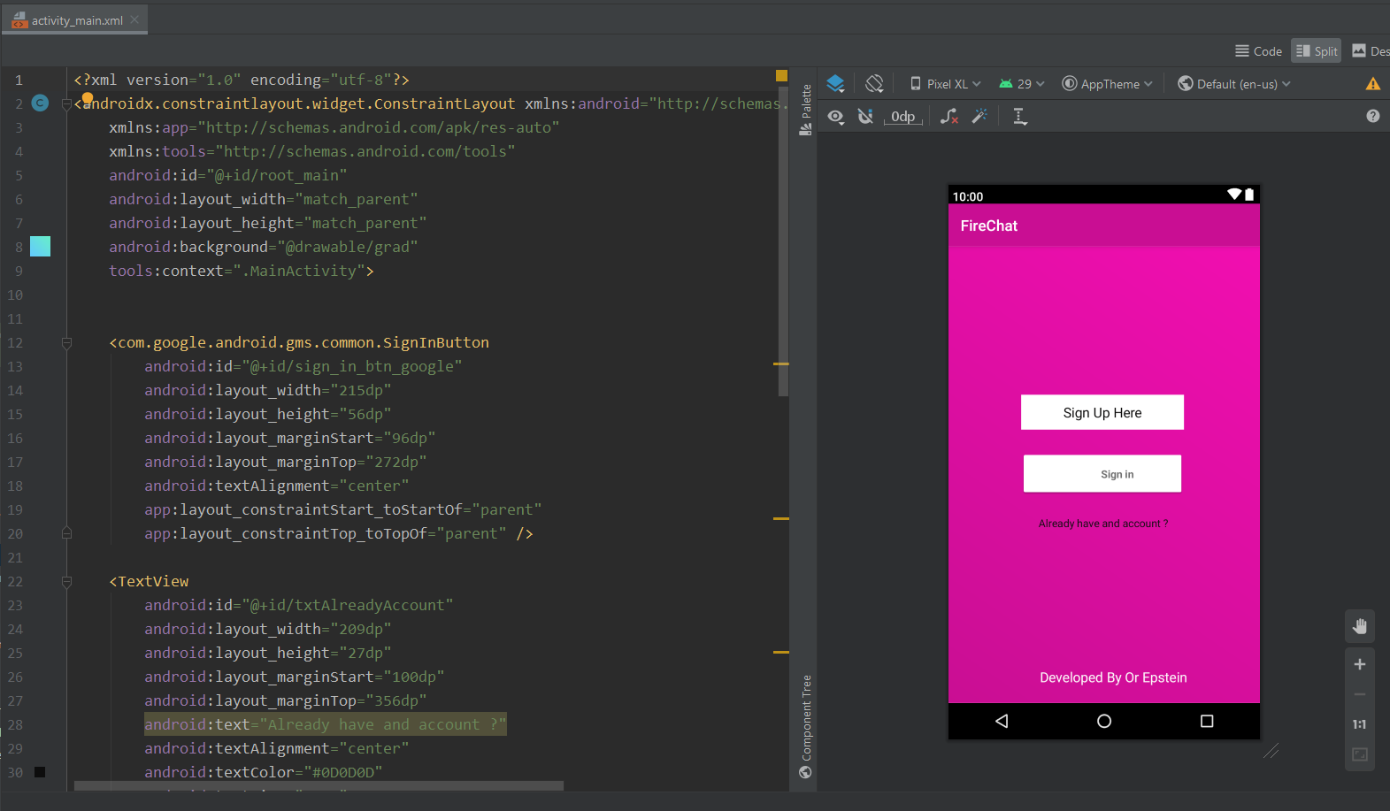  
  
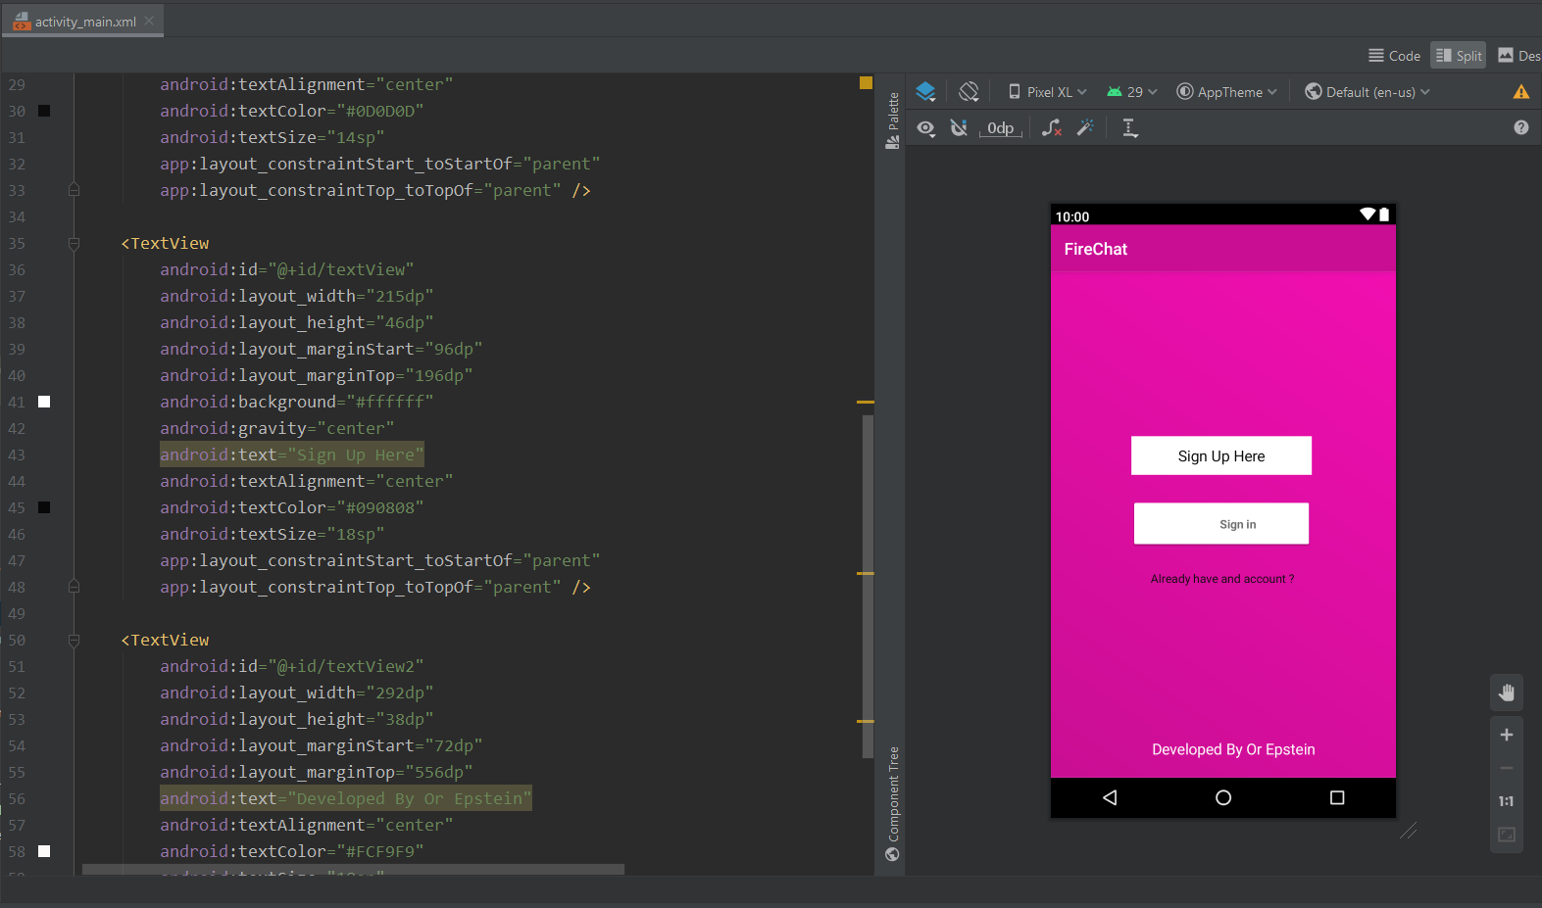  
  
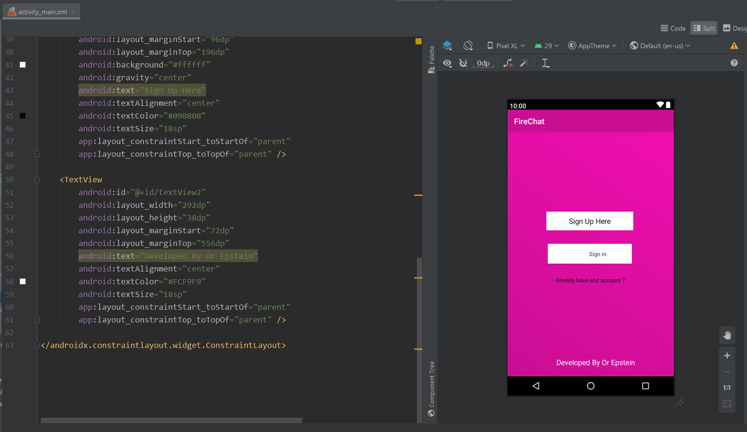  
  
  
Newmassage  
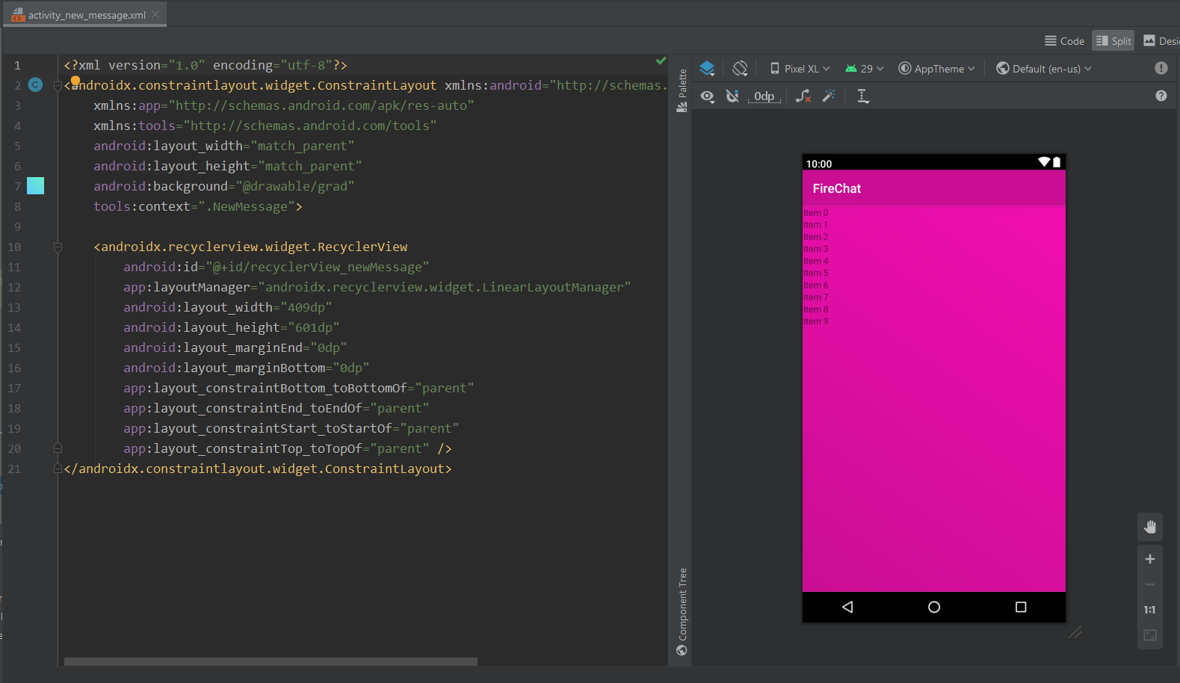  
  
profileXml  
  
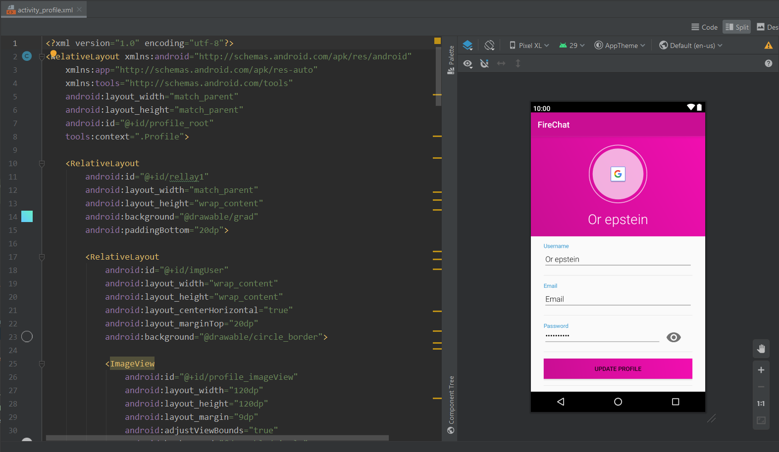  
  
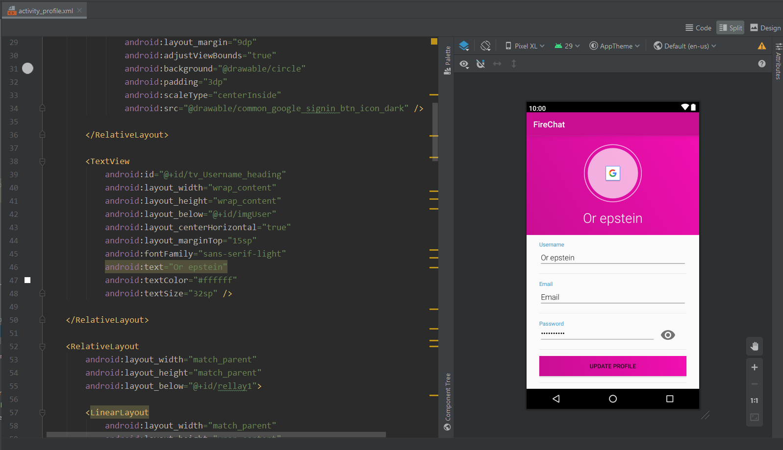  
  
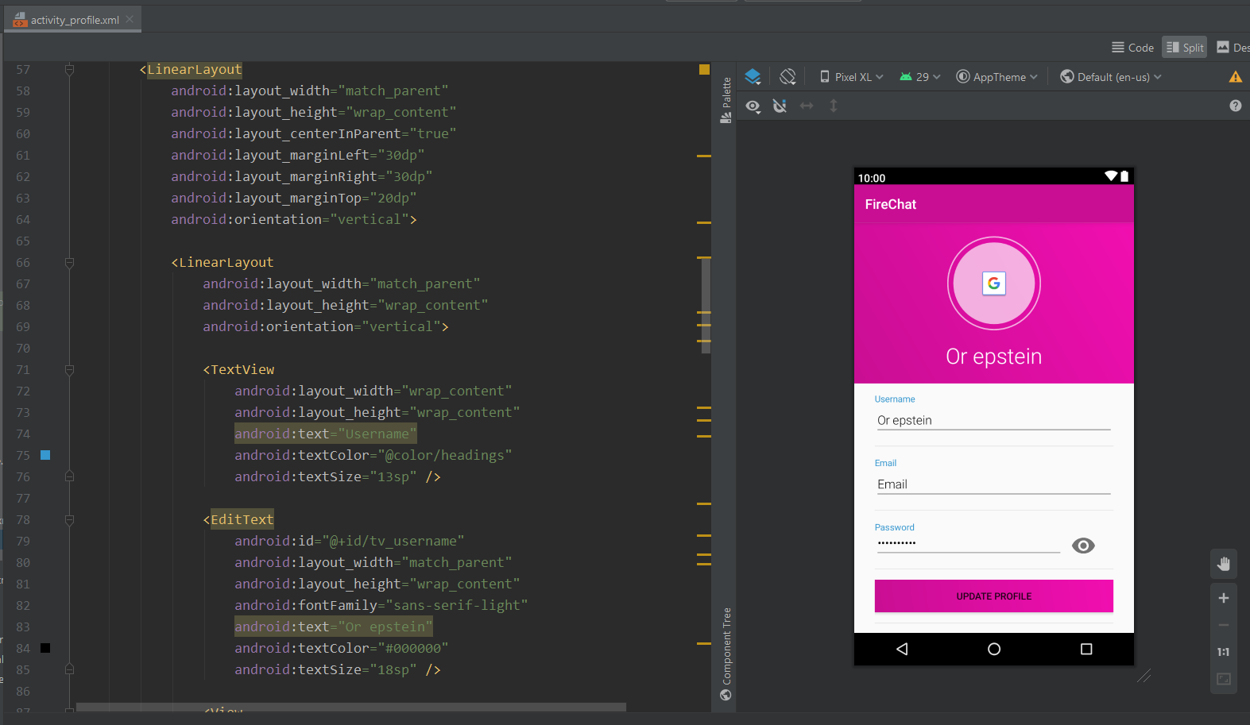  
  
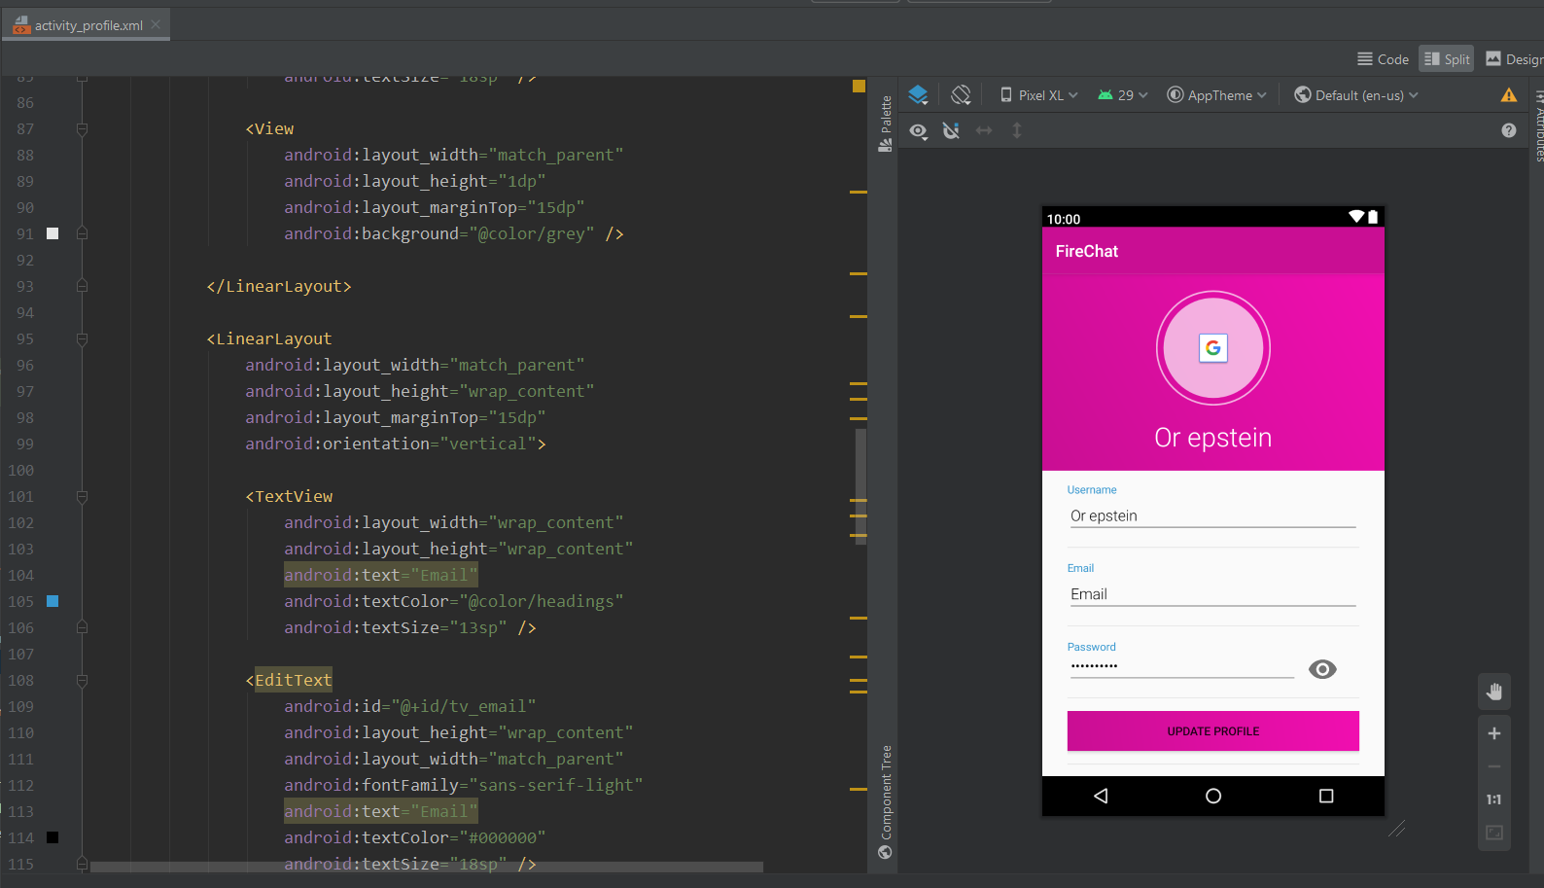  
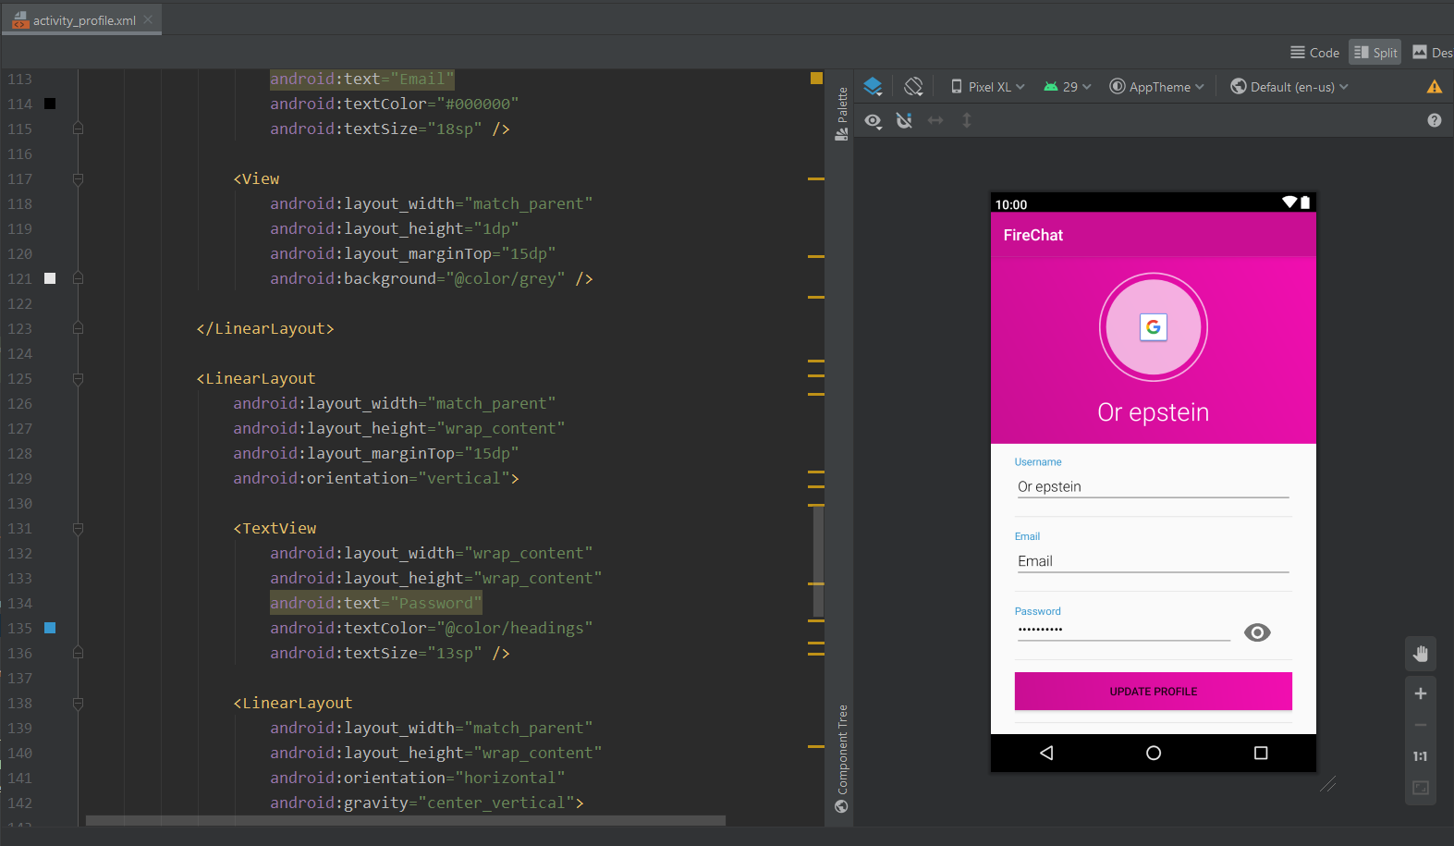  
  
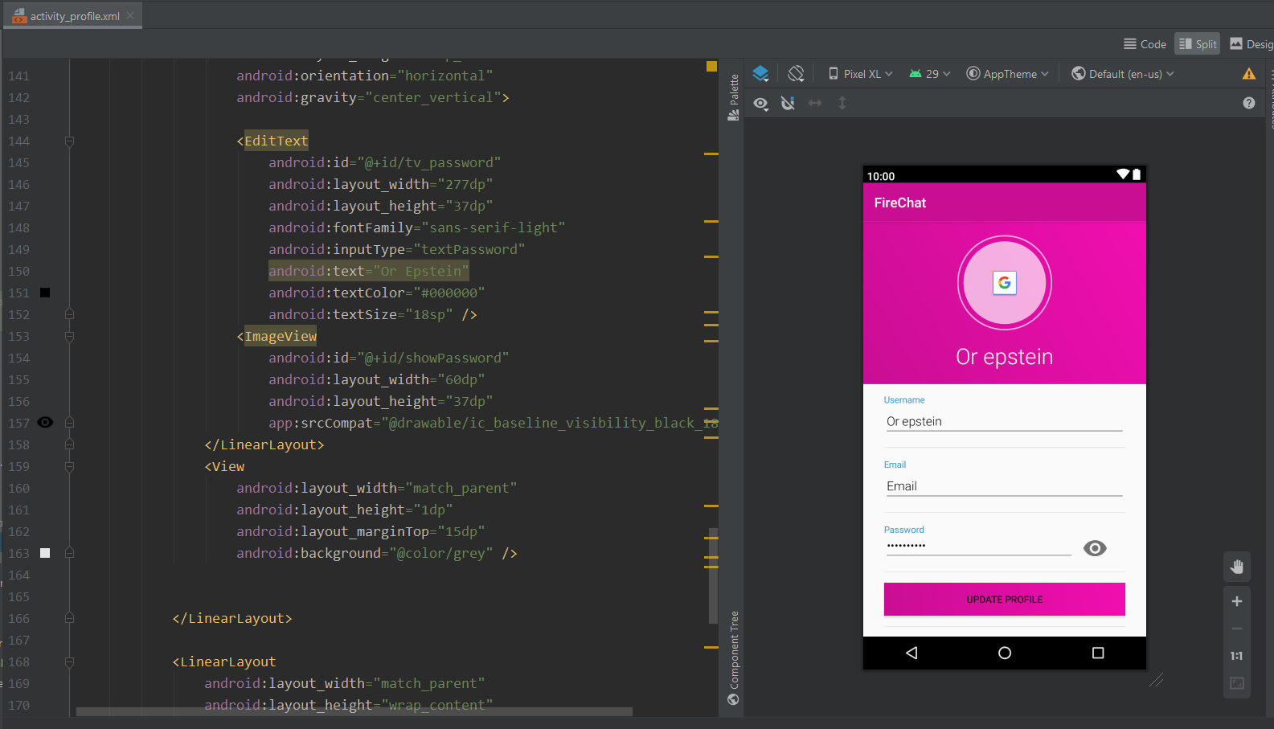  
  
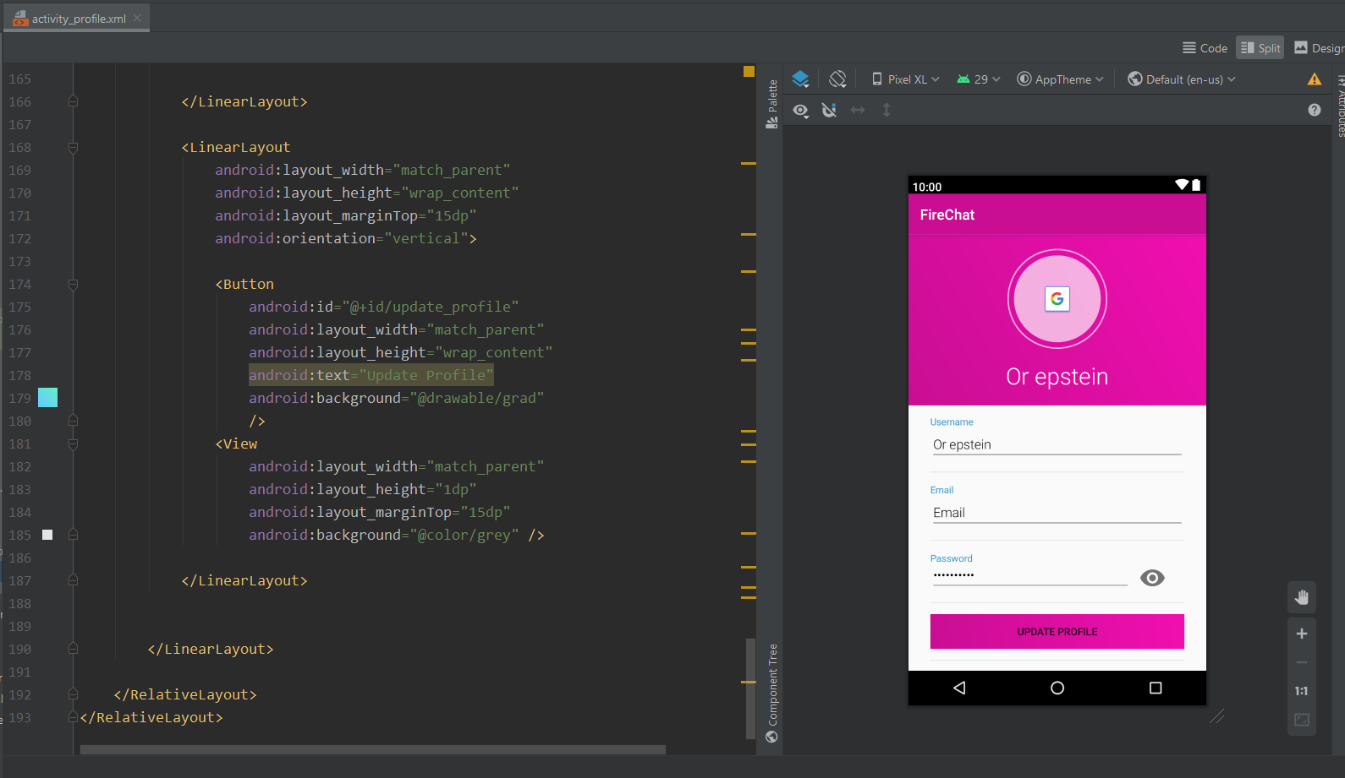  
  
  
  
shareFiles  
  
  
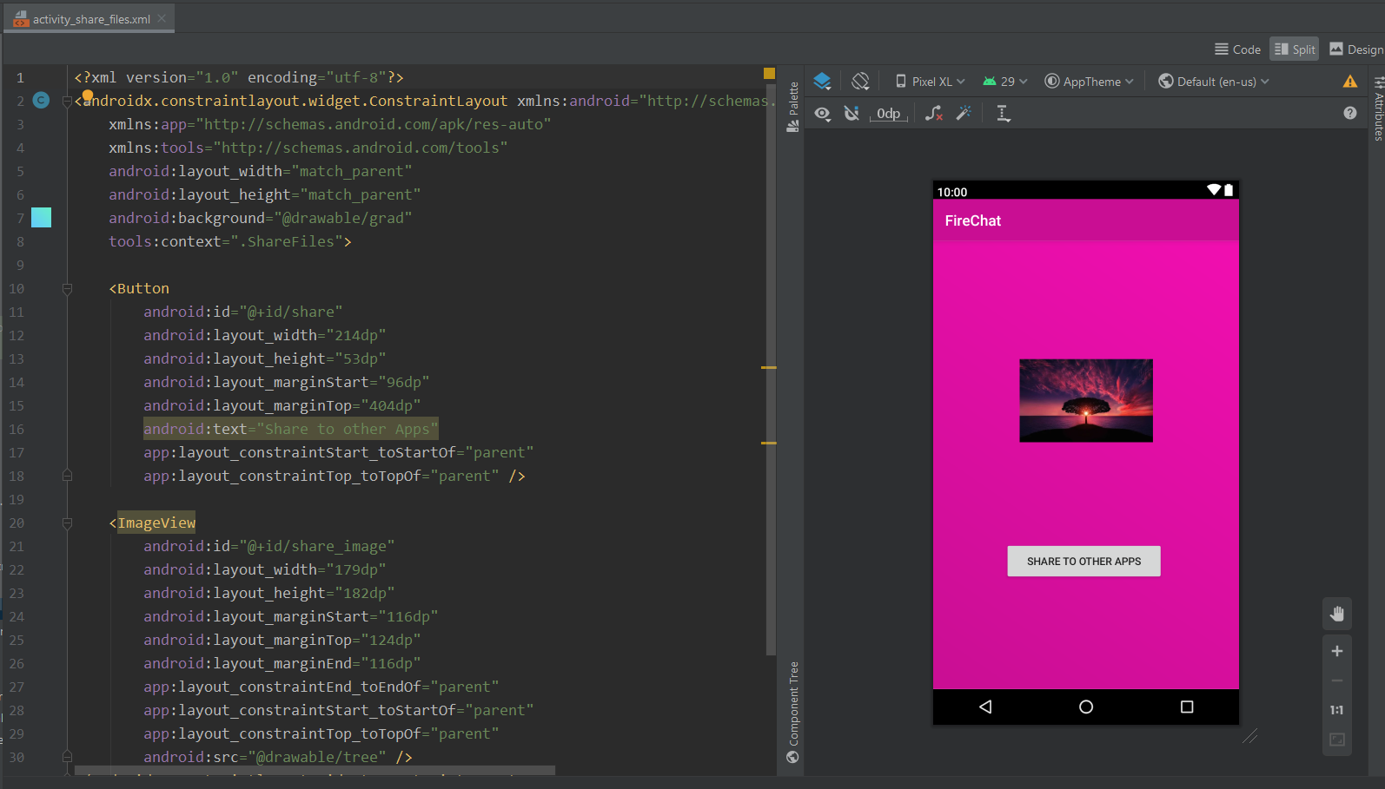  
  
  
  
  
  
  
  
  
  
  
  
  
  
  
  
  
  
splashScreen  
  
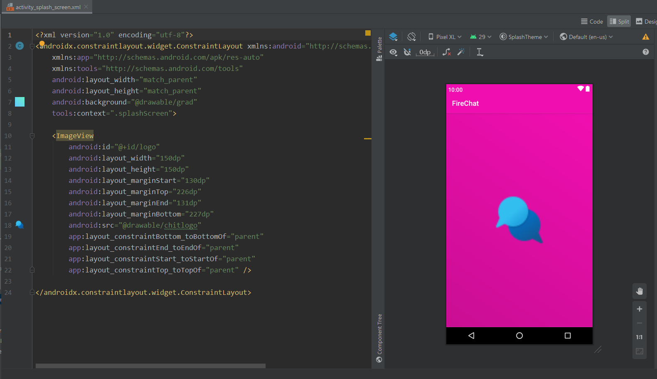  
  
  
  
  
  
  
  
  
  
  
  
  
  
  
  
chatFromRow  
  
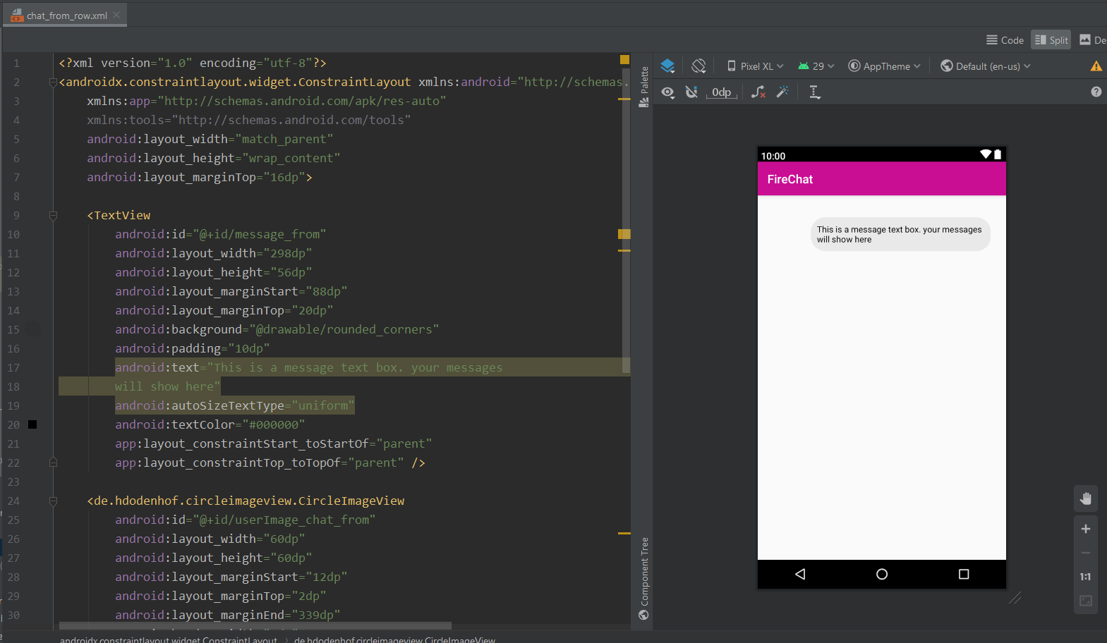  
  
  
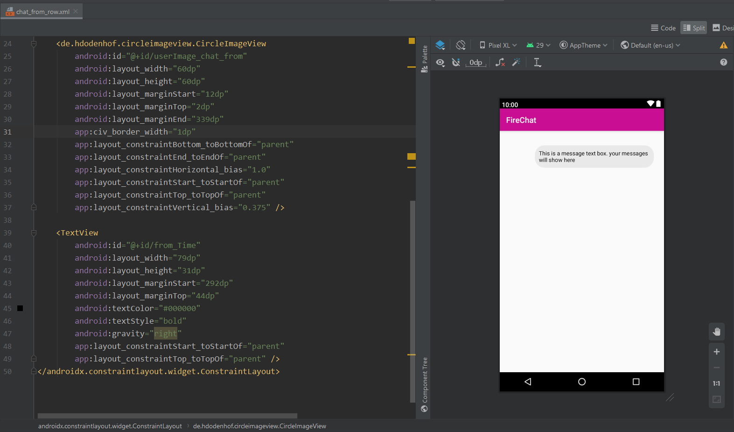  
  
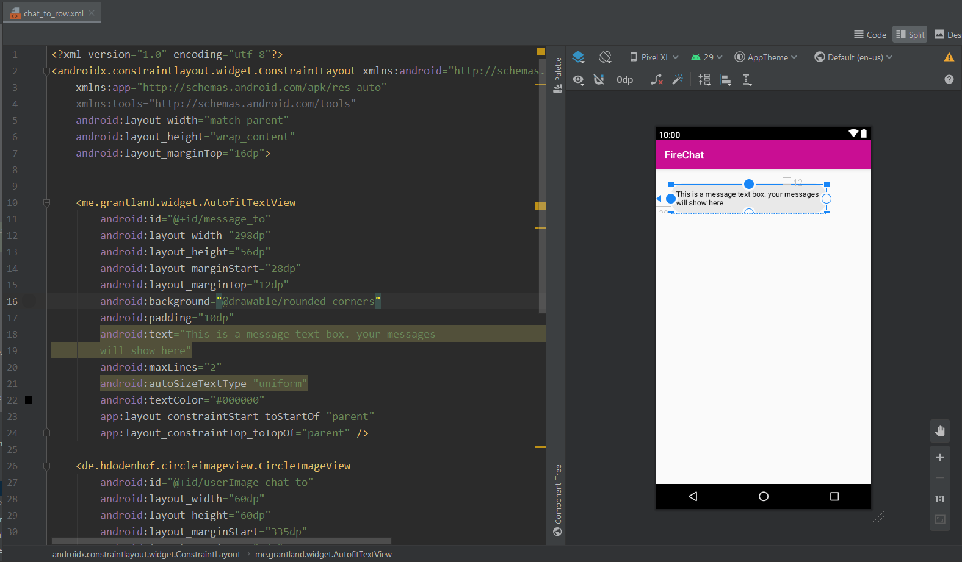  
  
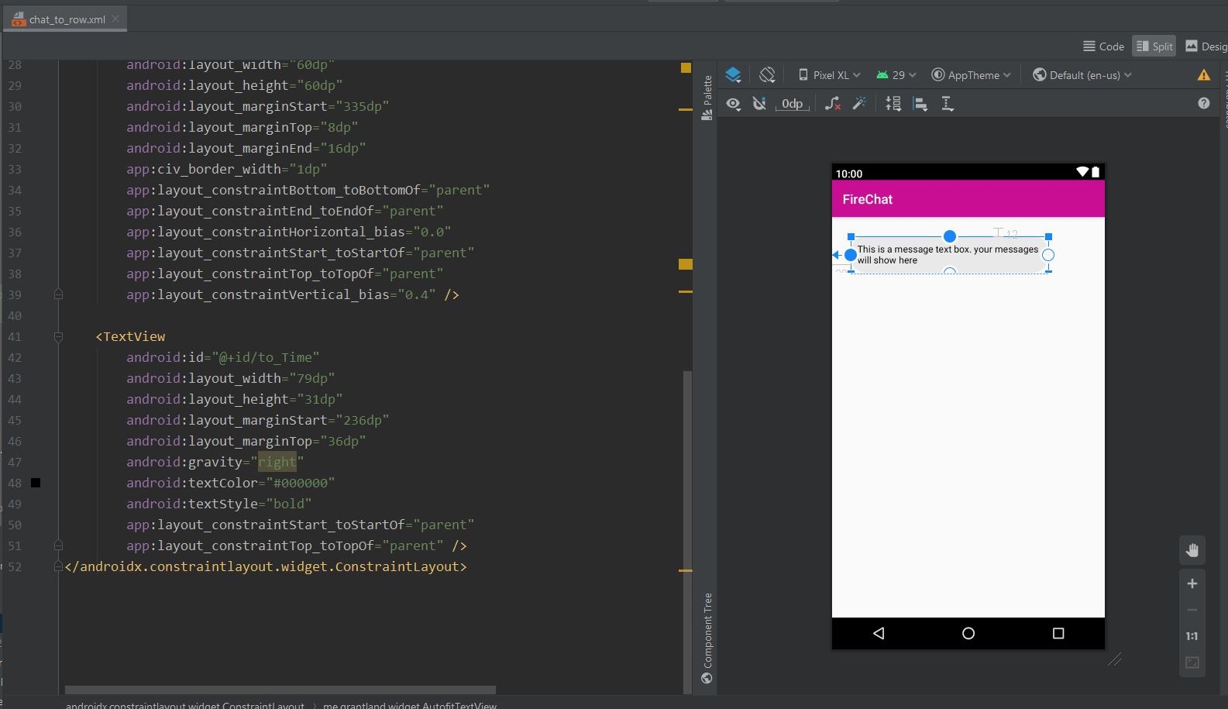  
  
  
  
forgetPass  
  
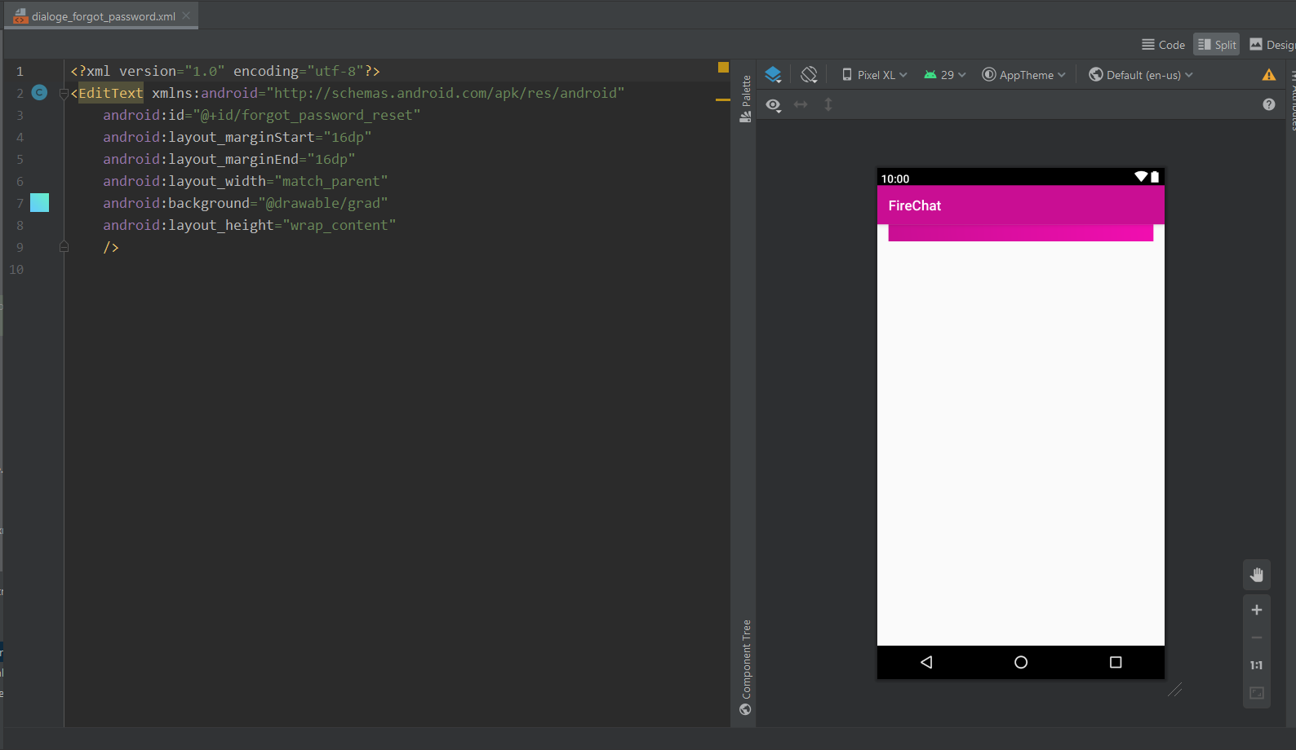  
  
  
  
  
  
  
  
  
  
  
  
  
  
  
  
  
latestMsgRow  
  
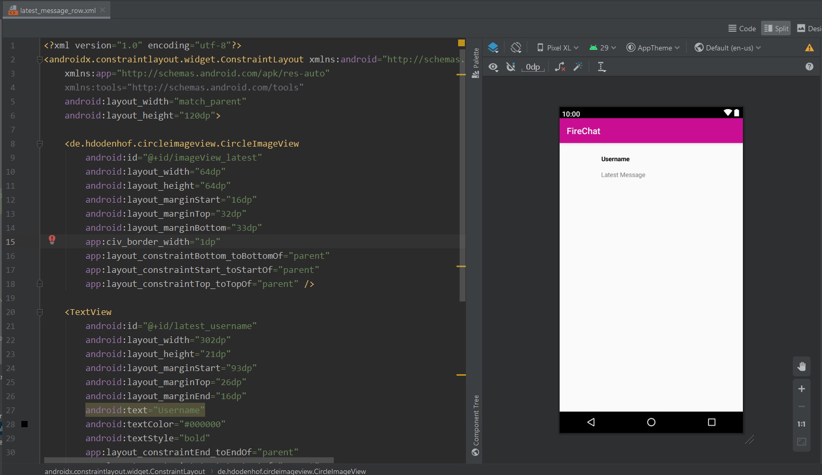  
  
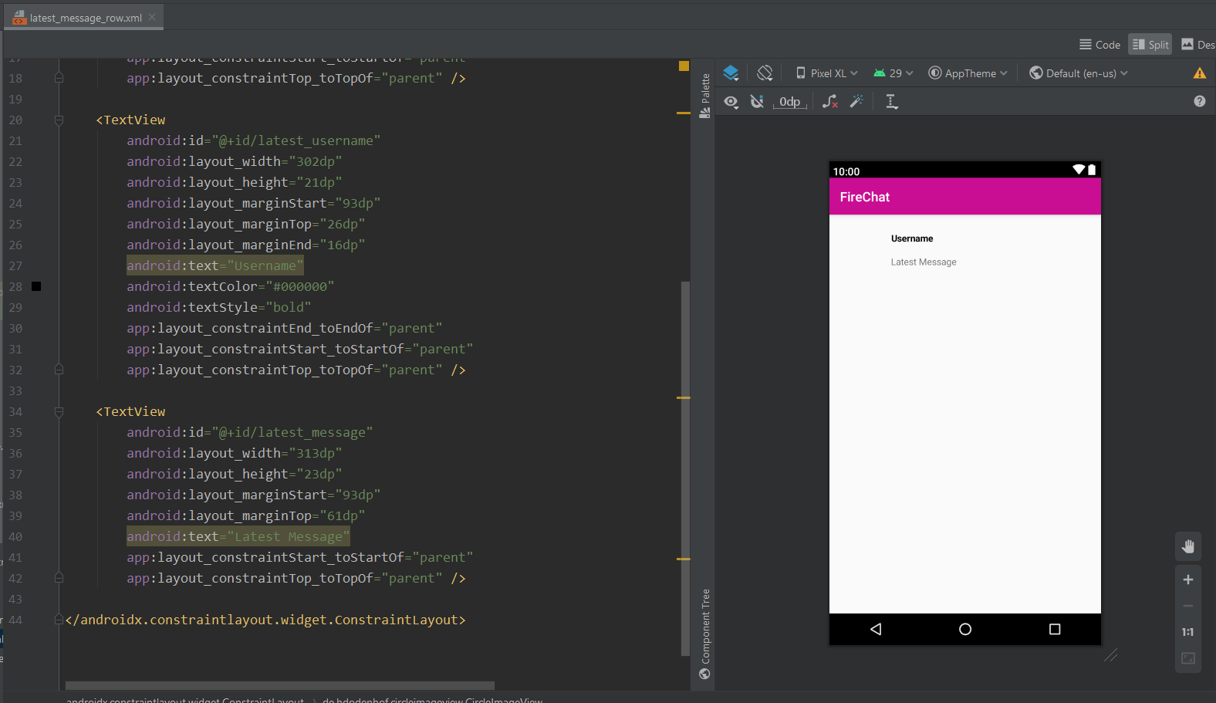  
  
  
  
userRowNewMsg  
  
